 | rab/bit vc/cv | 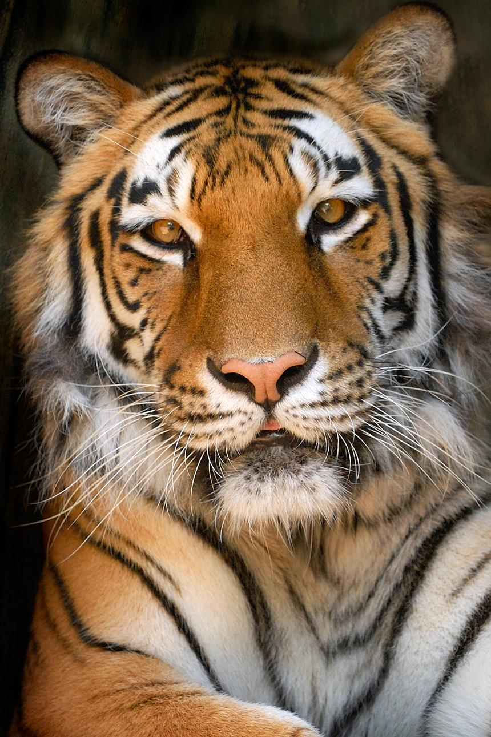  ti/ger  v/cv
magnet
optic
gravy
erase
climax
confuse
tiny |  | 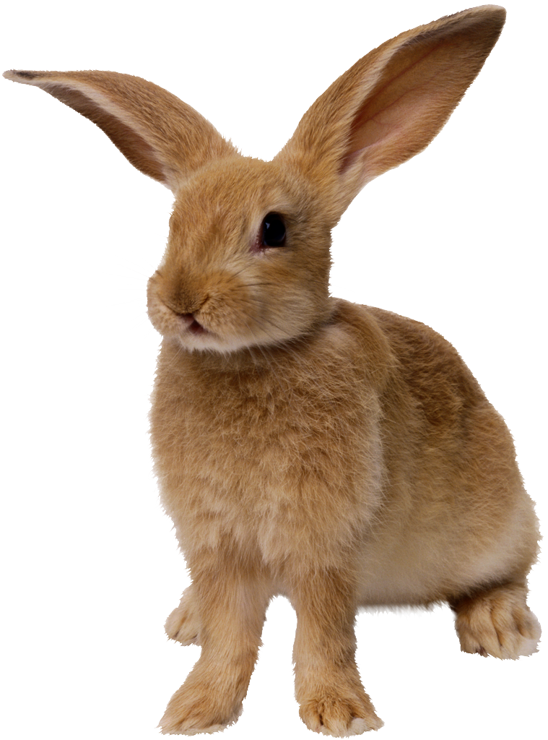
costume
halo
splendid
pancake
pony
raven
infect
rotate

