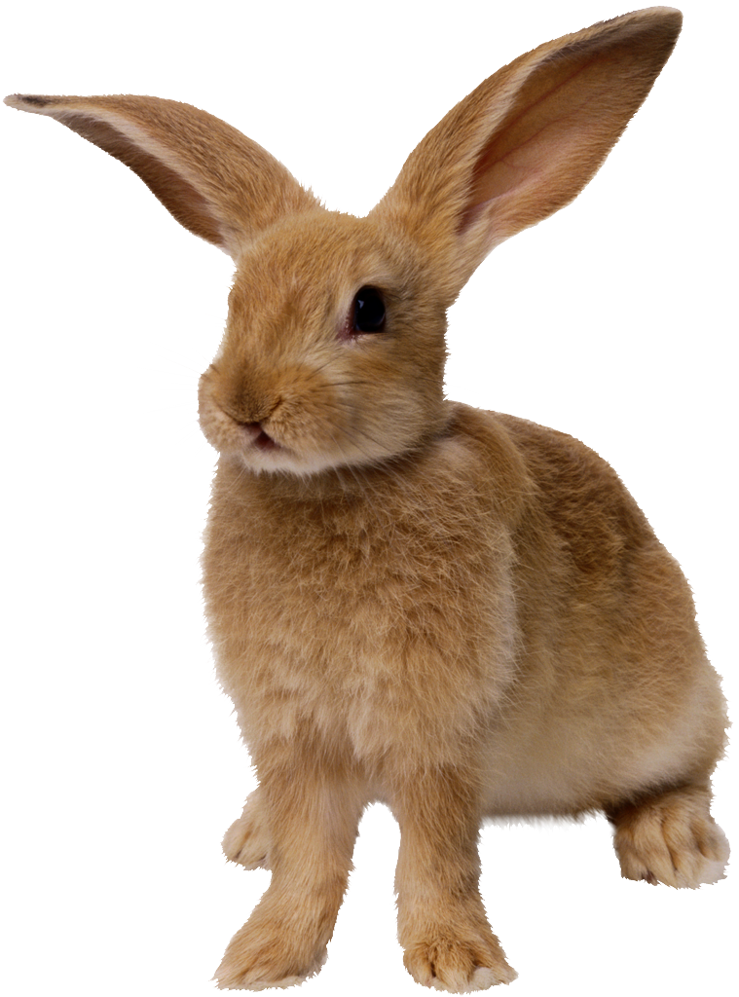 vccv(er)
Dot the vowels.
Underline the middle consonants.
Scoop the word.
Write the syllables.

rabbit | rab | bit
butter
dinner
hammer
ladder
letter
manner
pepper
rubber
suffer
copper
bitter
matter
supper
zipper

vccv(er)
Dot the vowels.
Underline the middle consonants.
Scoop the word.
Write the syllables.

rabbit | rab | bit
butler
enter
lumber
member
temper
timber
under
tender
winter
number

vccv(er)
Dot the vowels.
Underline the middle consonants.
Scoop the word.
Write the syllables.

rabbit | rab | bit
expert
adverb
lantern
servant
Vermont
perfect
verdict
persist
serpent
berserk

Dot the vowels.
Underline the middle consonants.
Scoop the word.
Write the syllables.

vccv(ar)
rabbit | rab | bit
artist
carpet
garden
market
target
carton

garlic
jargon
garnet

Dot the vowels.
Underline the middle consonants.
Scoop the word.
Write the syllables.

vccv(ar)
rabbit | rab | bit
carcass
harness
scarlet
garment
parsnip
harvest
discard
bombard
garnish
sharpen

vccv(or)
Dot the vowels.
Underline the middle consonants.
Scoop the word.
Write the syllables.

rabbit | rab | bit
horrid
afford
torrent
correct
orbit
organ
forget
hornet
snorkel
torment

vccv(or)
Dot the vowels.
Underline the middle consonants.
Scoop the word.
Write the syllables.

rabbit | rab | bit
absorb
distort
mortal
inform
platform
forlorn
border
corner
order
perform

vccv( ur)
Dot the vowels.
Underline the middle consonants.
Scoop the word.
Write the syllables.

rabbit | rab | bit
current
turban
turnip
burlap
surplus
furnish
absurd
disturb
murmur
perturb

vccv(ir)
Dot the vowels.
Underline the middle consonants.
Scoop the word.
Write the syllables.

rabbit | rab | bit
stirrup
affirm
infirm
squirrel
girlish
confirm
skirmish
firmness
thirty
circus

vccv(mixed)
Dot the vowels.
Underline the middle consonants.
Scoop the word.
Write the syllables.

rabbit | rab | bit
sister
morbid
urban
farmer
splinter
further
serpent
thunder
undershirt
carpenter

vc/cvce
Dot the vowels.
Underline the middle consonants.
Scoop the word.
Write the syllables.

rabbit | rab | bit
perfume
surprise
termite
perspire
surmise

