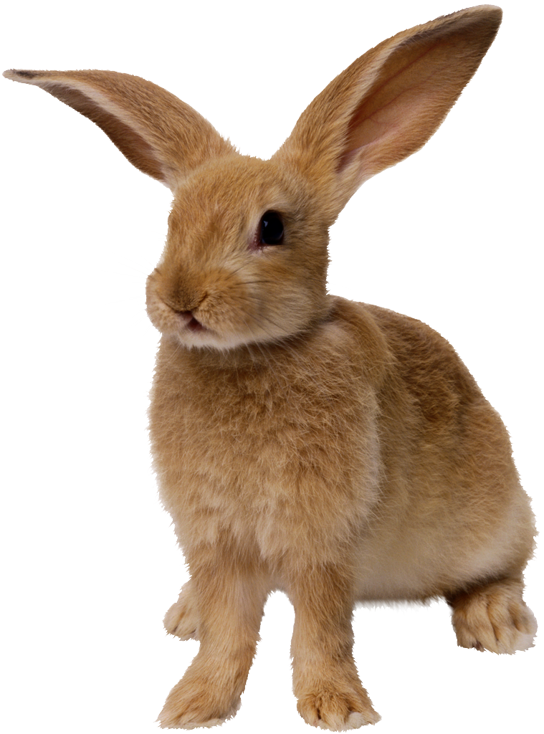 vccv
Dot the vowels.
Underline the middle consonants.
Scoop the word.
Write the syllables.

rabbit | rab | bit
pigpen
hotrod
catnip
cobweb
sunset
laptop
hatbox
suntan
bedbug
tiptop

vccv
Dot the vowels.
Underline the middle consonants.
Scoop the word.
Write the syllables.

rabbit | rab | bit
nutmeg
mascot
napkin
goblin
admit
picnic
combat
submit
misfit
plastic

vccv
Dot the vowels.
Underline the middle consonants.
Scoop the word.
Write the syllables.

rabbit | rab | bit
absent
expect
insult
invent
contest
disrupt
spandex
chipmunk
whiplash
backpack

vccv(suffix s)
Dot the vowels.
Underline the middle consonants.
Scoop the word.
Write the syllables.

rabbit | rab | bit
sunsets
bedbugs
unzips
tenpins
tomcats
cobwebs
napkins
bathmats
chipmunks
dishpans

vc/cvce
Dot the vowels.
Underline the middle consonants.
Scoop the word.
Write the syllables.

rabbit | rab | bit
tadpole
invade
combine
dislike
reptile
escape
ignite
inhale
compute
invade

vc/cvce
Dot the vowels.
Underline the middle consonants.
Scoop the word.
Write the syllables.

rabbit | rab | bit
pancake
flagpole
trombone
clambake
humdrum

campfire
stampede
shinbone
sunshade

athlete

