v
c
Closed Syllable

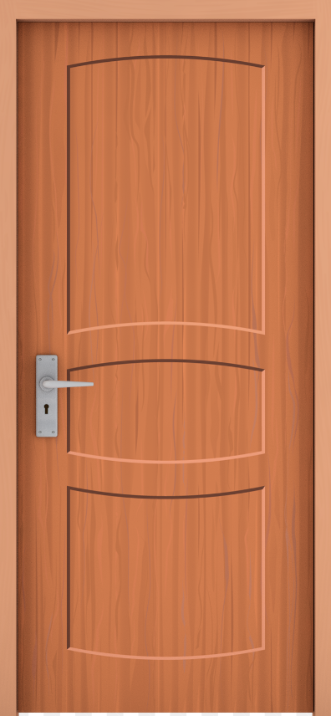
v
c
Closed Syllable


v
c
Silent-e Syllable
e

v
c
Magic-e Syllable
e

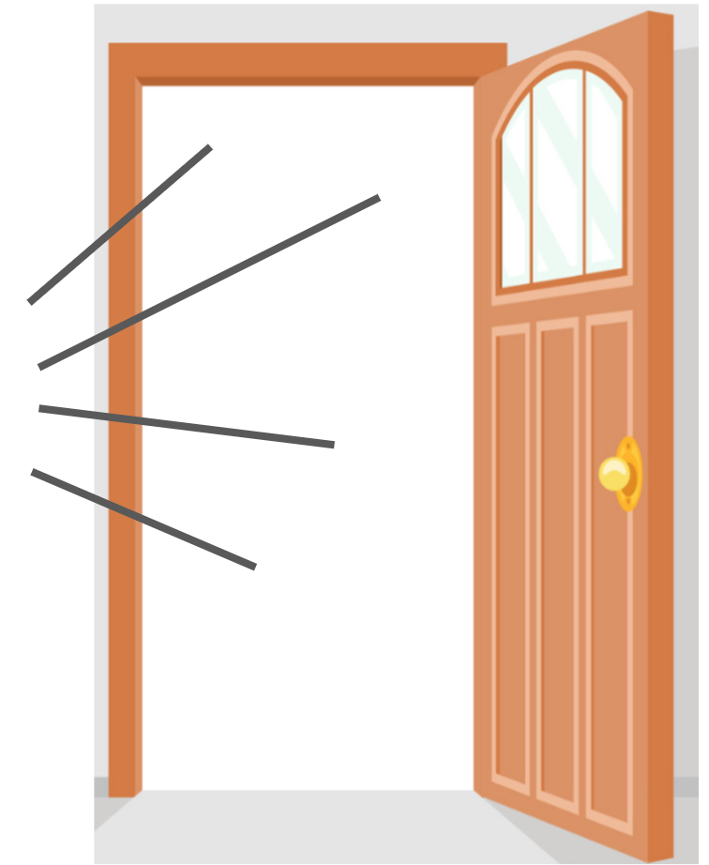
v
Open Syllable

v
Power-r Syllable
r
ar, or, er, ir, ur


v
Power-r Syllable
ar, or, er, ir, ur

v
r-Control Syllable
ar, or, er, ir, ur

v
Bossy-r Syllable
ar, or, er, ir, ur




v
Vowel Team Syllable
t
ee, oo, ay, oa, ea, ou, igh, ow, ai, oy, au

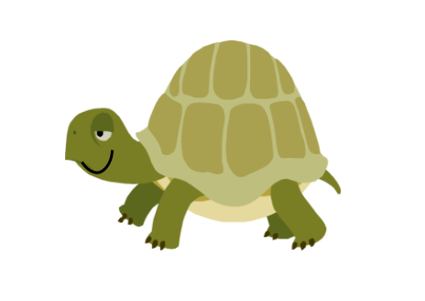
Consonant-le Syllable
-cle
-ble, -tle, -fle, -ple, -dle



