Name:__________________________ Date: _____________________

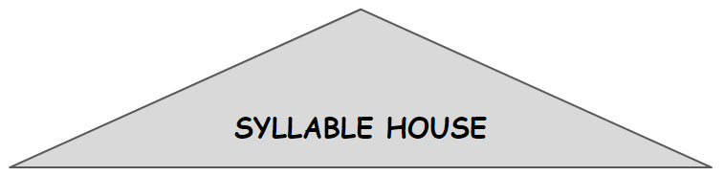
Vowel Teams
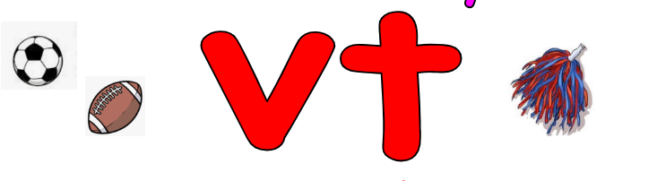  ai | ay
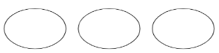

Name:__________________________ Date: _____________________

Vowel Teams
oa | ow

Name:__________________________ Date: _____________________

Vowel Teams
oi | oy
Name:__________________________ Date: _____________________

Name:__________________________ Date: _____________________

Vowel Teams
ai oa oi  Middle | ay ow oy  End
