GRADE 2 REVIEW OR GRADE 1 INTRO AFTER LEARNING VOWEL TEAMS INDEPENDENTLY
Spelling by Position focusing on VT vowel teams
Task - step in lesson | ai - ay | oa-ow | oi - oy
 | AI- AY SLIDES CLICK HERE | OA-OW SLIDES CLICK HERE | OI-OY SLIDES CLICK HERE
Cards- 10 (cards/ doc camara/slides)  Vowels - rotate say name & sound  Cons - sounds unless spell. poor | a l ai n ch  oa m ay b c | b ay oa ch a  ow k x o l | b oy oa c ay  oi k x oa l
Phoneme-Grapheme Mapping-5-6  Vowel = red = heart of word  Trickiest part of a word  - Say a word -They repeat it  - Say the Sounds & pull down chips or TAP  - Say the word  - Where is the vowel sound? | main  bay  lay  chain  waist  stay | mow  coat  flow  boast  hoax  grow | coin  toy  coy  point  void  boil  boy
Reading Words 10-20  DISCOVER Reading of word list & looking & doing  - Highlight vowel team  - What is the vowel team?  - What is the sound?  - Where is the vowel sound?  MODEL & REINFORCE mid/end  PAIRS ACTIVITY WORKSHEET SORT  - Sort words middle / end of a word or end of a syllable  - Then each student write the words on their own worksheet  Follow up SMALL Group If needed:  See the word - ph-gr mapping—>  Say the sounds pull - chips  Where is the vowel sound | DISCOVER w/ word list  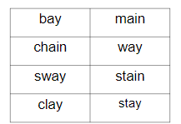  MODEL & REINFORCE:  main  ai says /long a/ middle  bay  ay says /long a/ end  Middle End  PAIRS ACTIVITY WORKSHEET SORT | DISCOVER w/ word list  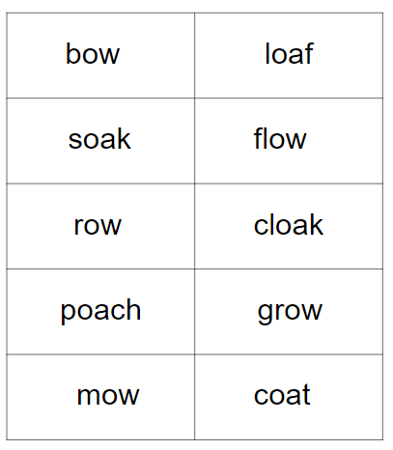  MODEL & REINFORCE:  loaf bow  Middle End  PAIRS ACTIVITY WORKSHEET SORT | DISCOVER w/ word list  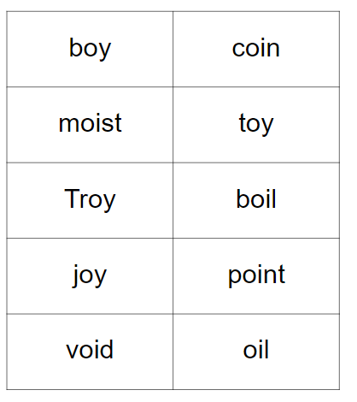  MODEL & REINFORCE:  coin boy  Middle End  PAIRS ACTIVITY WORKSHEET SORT
Spelling of Sounds 5 & Words 5-7- SOS  - Say the word -They repeat it  - Tap or chips -DECIDE mid/end  - Spell word saying sounds or letters  - Check & spell the word  Phoneme grapheme boxes sheet  Or Columns: Middle End | /short a/, /ch/, /m/, /l/  /long a/ = a, a-e, ai, ay  main  bay  lay  chain  waist  stay  spray | /short o/, /k/= c,k, ck , /r/,  /long a/ = a, a-e, ai, ay  /long o/ = o, o-e, oa, ow  mow  toad  loaf  bow  boast  cloak throw | /short o/, /v/ , /j/,  /long a/ = a, a-e, ai, ay  /oi/ = oi, oy  /long o/ = o, o-e, oa, ow  toy  join  void  oy moist  soil soy
Reading decodable passage /story or authentic text  Read & find targeted word patterns | Links -- ai ay =/long a/  Read Live passages ai ay  UFLI text ai ay | Links -- oa ow = /long o/  Read Live passages oa  Read Live passages ow  UFLI text oa ow | Links -- oi oy = /oi/  Read Live passages oioy  UFLI text oi oy
BONUS SLIDES! | ROLL & READ | ROLL & READ | ROLL & READ

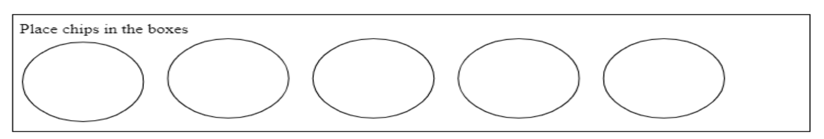

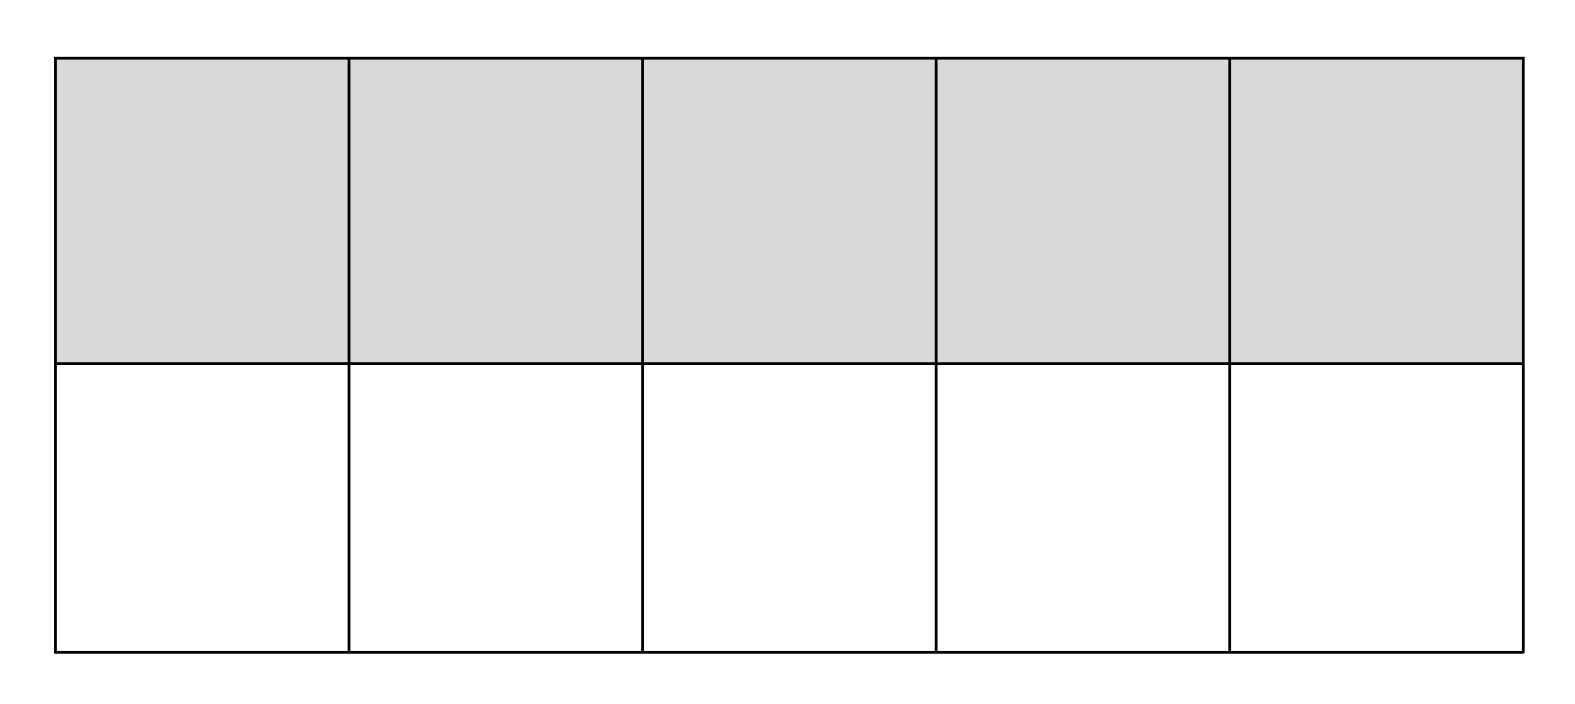

Name:__________________________ Date: _____________________

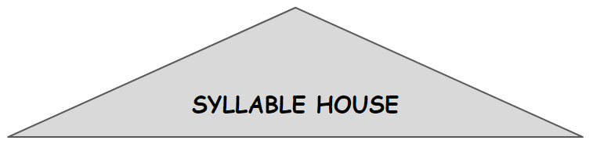
Vowel Teams
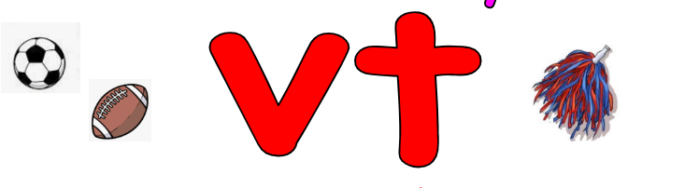  ai | ay
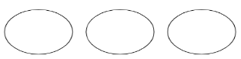
Name: _______________________ Date: ____________________

1. | 2. ___, ____, ____,_____
3. | 4. ___, ____, ____,_____

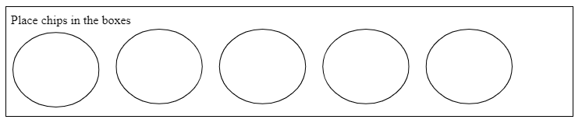

Name:__________________________ Date: _____________________
Vowel Teams
oa | ow

Name:__________________________ Date: _____________________

Vowel Teams
oi | oy

Name:__________________________ Date: _____________________

Name:__________________________ Date: _____________________

Vowel Teams
ai oa oi  Middle | ay ow oy  End
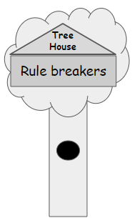

Name: _______________________ Date: ____________________

1. | 2. ___, ____, ____,_____
3. | 4. ___, ____, ____,_____

