GRADE 2 REVIEW Open & Closed syllable types & INtro Tiger / Robin syllable division rules
REVIEW Open & Closed syllable types &
INTRO Tiger / Robin syllable division rules
Open /Closed review → Tiger & Robin Intro
HANDOUTS
Lesson onSmartnotebook click here | Lesson on G-Slides click here
Cards- 5-10 (cards)
a e i o u
Review rabbit rule if needed
Phonological Awareness  Say the syllable - students repeat it --crouch short/ reach up for long  Cab pi ha top e hab stu  Phoneme Map/chips together  Top ha stu men lo si trav  Focus & awareness of pattern and sound | 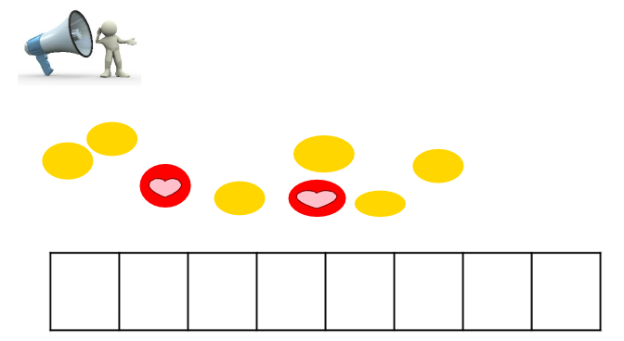  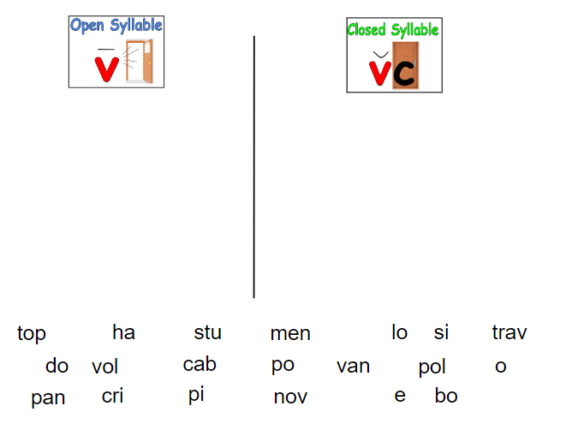
Explicitly name open /closed
Can have students use whiteboards to write while sorting
DISCOVER  TIGER SYLLABLE DIVISION INTRO  LISTEN - MAP  solo remote crisis  DISCOVER w/ word list  Look & mark up words as students respond.  MODEL & REINFORCE:  Explicitly state tiger rule → especially open first syllable  ROBIN SYLLABLE DIVISION INTRO  LISTEN - MAP  Vanish cabin topic  DISCOVER w/ word list  Look & mark up words as students respond  MODEL & REINFORCE:  Explicitly state robin rule → especially open first syllable | 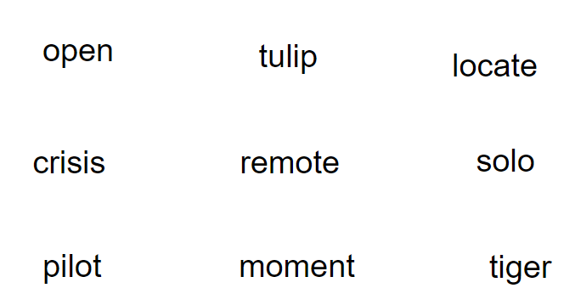  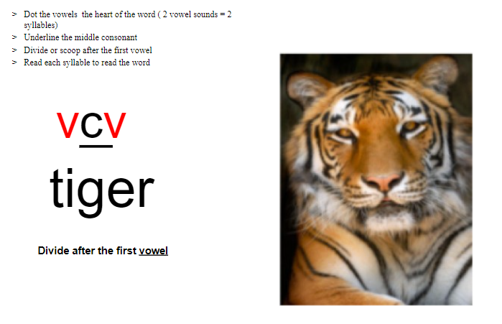  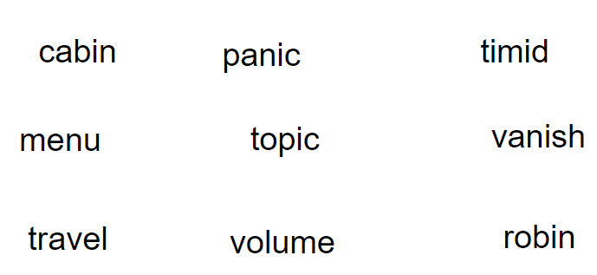  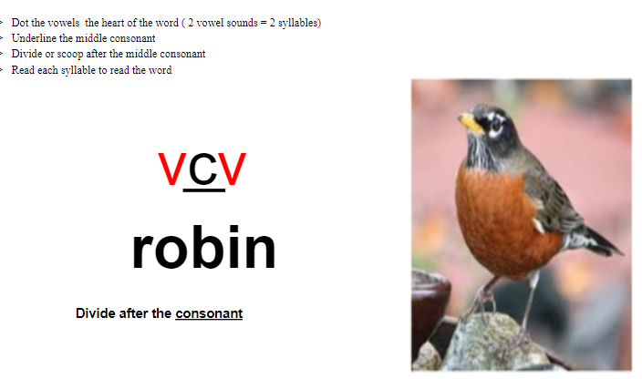
PAIRS ACTIVITY WORKSHEET SORT  Sort words TIGER / ROBIN  MODEL & REINFORCE:  SYLLABLE DIVISION STEPS  DOT VOWELS  UNDERLINE MIDDLE CONSONANT  DECIDE & DIVIDE  Model a few words of the sort  Students have pairs or groups to sort words then they WRITE the words. | 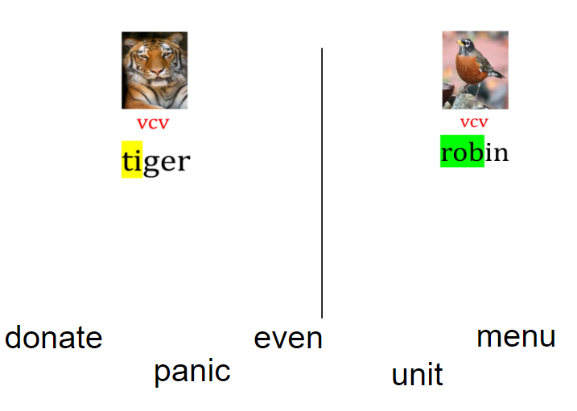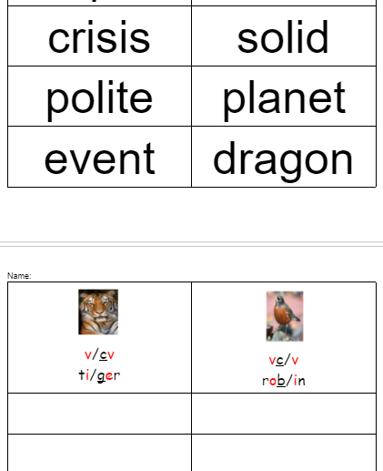
Speling of Sounds 5 &  /short a/, /long a/ = a, a-e, ai, ay,  /short o/, /long i/ , /short u/, /short i/, /long u/  Words 5-7- SOS  Menu habit vanish solo  remote topic unit  SPELL SYLLABLE BY SYLLABLE THEN THEY WRITE THE WORD  OR CAN DO A SORT TIGER ROBIN AS SPELLING | 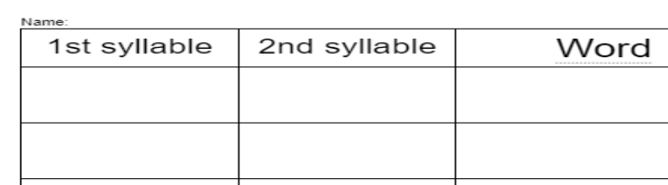
Reading decodable passage /story or authentic textFind tiger & robin words while reading - write on sticky notes

