Name___________________________
Real Words Sort
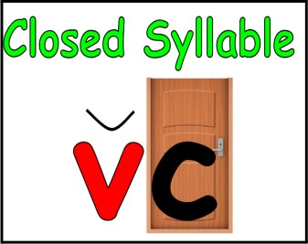
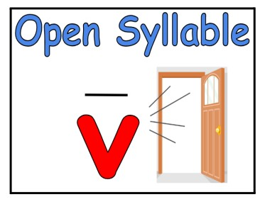

men | nod
no | by
shed | met
bet | she
lot | hi
hid | hop
be | a
at | ho
lo | hit
not | me

Name___________________________
Syllable Sort 1

What words can you make with these syllables?

stu | vent
nus | so
lent | e
bo | so
si | dent

Name___________________________
Syllable Sort 2

What words can you make with these syllables?

men | lo
ic | ven
van | u
e | ish
po | pan

Name___________________________
Syllable Sort

