Phoneme-Grapheme Mapping

t | a | b
s | t | i | ck
m | a | k_{e}
q | u | i | t
s | t | r | i | ng
f | a

- Always use one sound/ one phoneme per box.

- Spell words conventionally- no invented spelling.

- Students have grid paper, chips and a pencil. In large groups, teachers can use an document projector, chips, and a marker or an interactive smartboard with phoneme-grapheme sheet.

- Say the word and have the student repeat the word and then say the sounds as they pull down chips for the number of sounds in a word.

- Then, box-by-box, students push up the chip and write the grapheme(s), naming each letter aloud.

Prompts can include
What sounds do you hear?
What letters do you write?

- As they name the letters for each sound, they write them in each box.

- Tricky patterns:
digraphs (one box)
blends (two boxes)
qu (two boxes, close together)
x (across two boxes).

- Silent-e is mapped as having the silent-e in the corner of the box with the final consonant, as it has no sound.
- If they are using a box and line sheet they can rewrite the word on the lines

EXAMPLES
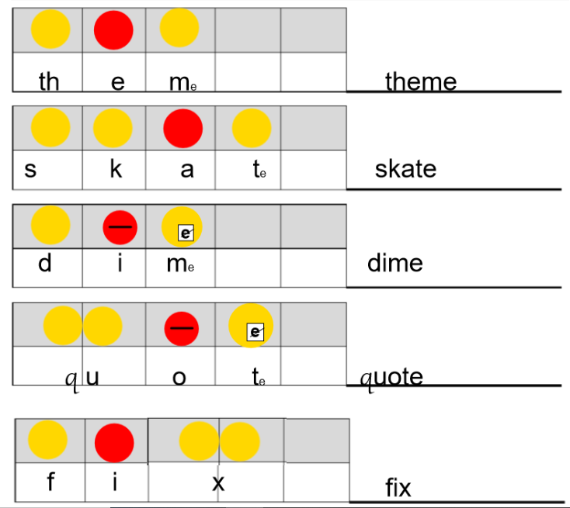

multi-syllable words - can segment both syllables → then spell both syllables or
segment 1st syllable & spell first syllable

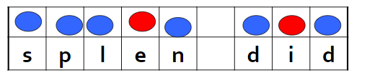

MANY DIFFERENT FORMATS BELOW FOR PHONEME-GRAPHEMES
SINGLE SET OF BOXES & SPELLING SHEETS

Name:

Name:

Place chips in this box

Name: _____________________Date:____________________

Place chips in this box

Place chips in this box

Name: ____________________ Date: __________________

Place chips in this box

Place chips in this box

Name: ___________________ Date: ___________________

Place chips in this box

Place chips in this box

Name: __________________ Date: _____________________

Place chips in this box

