Phoneme Mapping
/cat/

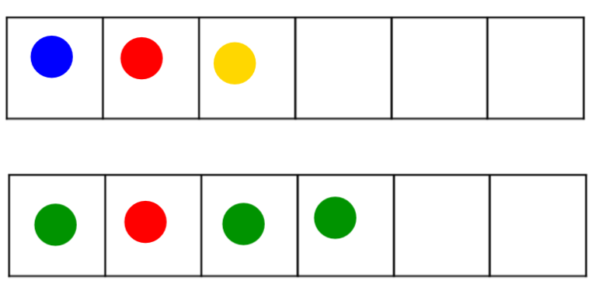
- Always use one sound/ one phoneme per box.

- Use ONE consistent color for the vowel (red or pink), one or varied colors can be used for consonants. It is the 💓 HEART of the word.

- Students have grid paper and chips. In large groups, teachers can use an overhead projector grid paper and chips, or an interactive smartboard with phoneme sheet.

- Say the word and have the student repeat the word and then say the sounds as they pull down chips for the number of sounds in a word.

- Prompts can include
What sounds do you hear?

- Tricky patterns: (samples next page)
digraphs (one box)
blends (two boxes)
qu /qw/ (two boxes, close together)
x /ks/ (two boxes)

/theme/



/skate/



/dime/



/fix/



/quote/



multi-syllable words - skip a space



