Lesson #:___________________ Date:_________
Student(s): ____________________________________ Teacher: __Joyce_______
Skill | Spelling focus Lesson Concept/Objective: -cle | -> The Turtle rule
Visual | Phonograms Cards:  All Single short / open vowels, ar, ir, ur, c, | CONSONANT - LE card-- PROCEDURE:  Say the letters -B L E read the word stable
Visual/Kinesthetic  TCC-A | SKILL/CONCEPT Review  Turtle rule ->  Count back three and divide | CAN DISCUSS HOW SOMETIMES USE THE RABBIT RULE FOR -CLE WORDS → THIS DOES NOT ALWAYS WORK --FOCUS ON TURTLE RULE - COUNT BACK THREE
Auditory  Phonemic Awareness of  NEW Phoneme | 1st set  Say wiggle, change /_wig __/ to / __gig__/  What is the new word?  (If needed: use hands/fists or blocks - change of 1st syllables)  Say giggle change gig to gar  What is the new word?  gargle / tangle / juggle | New set:  Say bubble, change bub to tum  What is the new word?  bubble / tumble /table / thimble / able  New set:  Say fiddle change fid to i  What is the new word?  idle / riddle / bundle / cradle  New set:  Say cattle change the cat to lit  What is the new word?  cattle / little / startle
Auditory/Visual  WORD BUILDING with NEW grapheme | Using a whiteboard : -gle, -ple at the top  start w/ juggle Change the /jug / to / tin / {tap it out}  juggle to tingle to giggle to shingle to tangle  start w/ topple Change the /top / to / sim / {tap it out} topple to simple to pimple to dimple to temple
Visual  Reading NEW  words in isolation | REVIEW SYLLABLE TYPES =  OPEN -- CLOSED --- VOWEL-R  READ  DETACHED syllable types TOGETHER & DO AN EXAMPLE OF SORTING THE SYLLABLES  SORT open - closed - vowel-r syllables  WRITE THE SORT  Think of words with -cle at the end to match up with the first syllables they sorted  Read words with second syllable is- consonant -le  Practice dividing count back 3 and divide
Visual  Reading NEW  words in context | PHRASES/SENTENCES (5-10)
Auditory  Dictated Sounds  Include NEW  SOS Procedure | 1. long a 2. /short i / 3. /sh / 4. /ar / 5. /er/  6. /long i / 7. The consonant -le in table→ - ble | 8. The consonant -le in title→ - tle  9. The consonant -le in wiggle→ -gle  10. The consonant -le in simple → - ple
Auditory  Focus on NEW  SPELLING Words & Sentences  SOS Procedure | 1. simple 2. marble 3. shingle 4. title  SENTENCES:  1. Little Hank will play and tumble all day.  2. I hope the team will not fumble the ball.  3. The shingle fell off the shed.  Can have them create sentences with -cle words | 5. able 6. idle 7. tumble 8. dimple 9. Garble  10 Sight Word
Visual | Follow up - find -cle words in their books

a | ir | c | ar | u
qu | o | ur | i | e

-ble | stable
-dle | saddle
-fle | rifle
-gle | bugle
-kle | pickle
-ple | simple
-tle | bottle
-zle | puzzle

an | rum | gar | sta | ap
jun | fum | tem | cir | i
mar | fa | bu | sim | sta
strug | no | fid | hum | driz
open |  | closed |  | vowel-r

Name__________________________ Date:_________________

1. | 2. | 3. | 4.
5. | 6. | 7. | 8.

Consonant -le Words
1st syllable / -le

1. ________/ __ __ __ ____________________

2. ________/ __ __ __ _____________________

3. ________/ __ __ __ _____________________

4. ________/ __ __ __ _____________________

5. ________/ __ __ __ ______________________

1st syllable | Open | Closed | Vowel-r
ex | title | bubble | gargle
6.
7.
8.
9.
10.

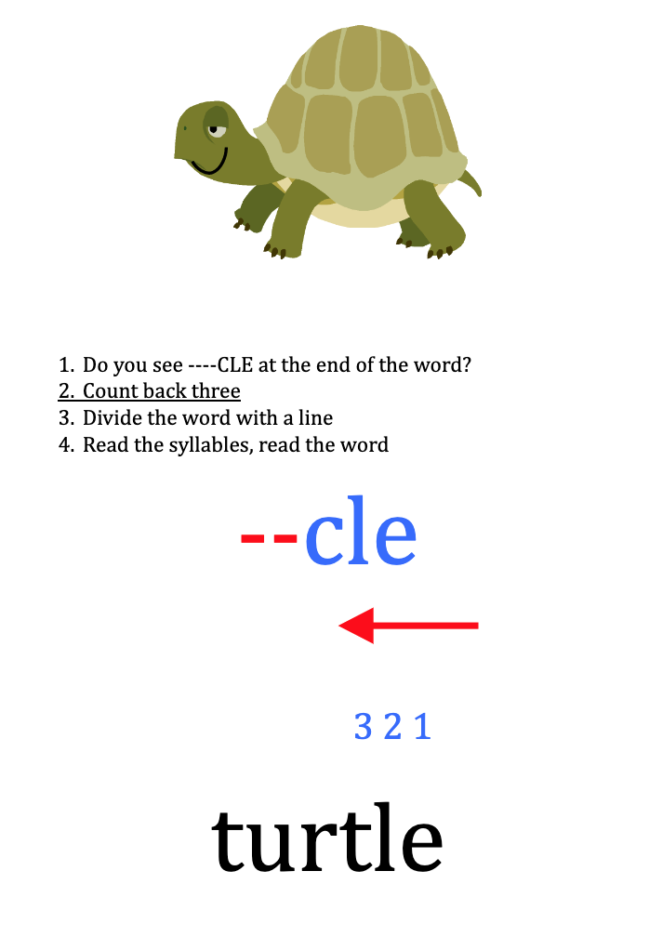

maple | ruffle | grumble
thimble | title | ladle
fable | dangle | puzzle
battle | gargle | candle
temple | uncle | gobble
fumble | noble | trample
staple | crumple | sizzle
uncle | circle | able
twiddle | hobble | mingle
nozzle | angle | dimple
stifle | idle | garble
brittle | kindle | ogle

Name:_____________________ Date:_____________

sim | gle |  | sta | dle
jun | ple |  | fid | ble
bu | tle |  | sim | ble
ti | ble |  | hum | ple
mar | gle |  | sta | ble

Consonant le words = -cle
open  1st syllable | closed  1st syllable | Vowel-r1st syllable
bible | bubble | turtle

Name: _________________ Date:________

driz | ple |  | gar | ble
sim | gle |  | sta | dle
sta | ple |  | fid | gle
jun | ble |  | cir | ble
tem | ble |  | hum | fle
mar | gle |  | sti | gle
bu | zle |  | strug | cle

Consonant le words = -cle
open  1st syllable | closed  1st syllable | Vowel-r  1st syllable
bible | bubble | turtle

sem | ble | re
gle | tan | rec
ple | ex | am

apple | aple
woble | wobble
shutle | shuttle
little | litle
cabble | cable
snifle | sniffle
tabble | table
fizzle | fizle
bugle | buggle
batle | battle
fabble | fable
wigle | wiggle
pebble | peble

hagle | haggle
idle | iddle
muzzle | muzle
ridle | riddle
staple | stapple
laddle | ladle
nible | nibble
bugle | buggle
struggle | strugle
medle | meddle
quible | quibble
scrible | scribble
abble | able

Name__________________________ Date:_________________

1. | 2. | 3. | 4.
5. | 6. | 7. | 8.

Consonant -le Words
1st syllable / -le

1. ________/ __ __ __ ____________________

2. ________/ __ __ __ _____________________

3. ________/ __ __ __ _____________________

4. ________/ __ __ __ _____________________

5. ________/ __ __ __ ______________________

1st syllable | Open | Closed | Vowel-r
ex | title | bubble | gargle
6.
7.
8.
9.
10.

