Name:__________________________ Date: _____________________

no | in | fun
the | she | him
got | you | me
man | so | love
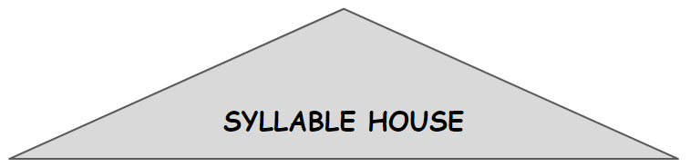
Open 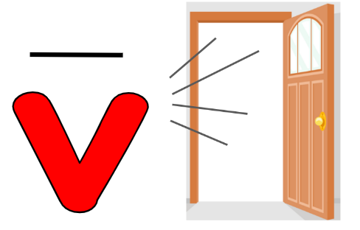 | Closed 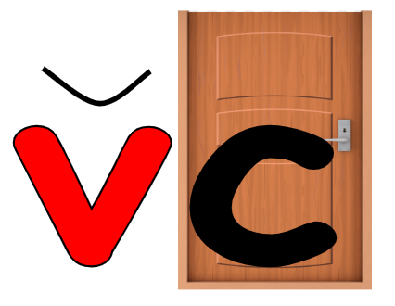
no | got
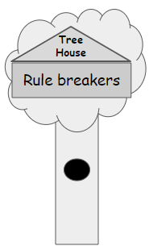

Name:__________________________ Date: _____________________

he | come | went
get | I | it
love | can | go
am | too | my
Open | Closed
no | got

Name:__________________________ Date: _____________________

will | on | by
cat | so | was
do | did | had
and | to | we
Open | Closed
no | got

Name:__________________________ Date: _____________________

wall | here | play
say | an | this
all | day | like
dad | ran | up
Closed | Silent-e 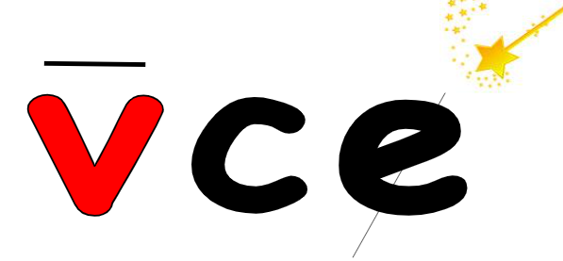
-all word family | Vowel Team 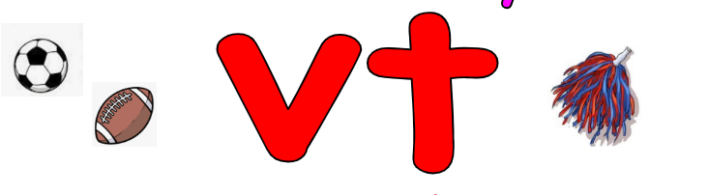  ay

Name:__________________________ Date: _____________________

ball | here | play
say | an | this
all | day | like
dad | ran | up
Closed | Silent-e
-all word family | Vowel Team  ay

Name:__________________________ Date: _____________________
Vowel Teams  oo ee ou ow oy | Vowel -r   ar er or ir

boy | see | park
you | how | look
has | mouse | girl
for | her | dog

What rhymes with…. |  | Add a word
Thor | for | nor
bee
log
Mark
took
toy
per
now
whirl
house
Lou
as

Name:__________________________ Date: _____________________

boy | see | park
you | how | look
has | mouse | girl
for | her | dog
Vowel Teams  oo ee ou ow oy | Vowel -r  ar er or ir

Name:__________________________ Date: _____________________

Open | Closed
no | got

no | in | fun
the | she | him
got | you | me
man | so | love

Name:__________________________ Date: _____________________

Open | Closed
no | got

he | come | went
get | I | it
love | can | go
am | too | my

Name:__________________________ Date: _____________________

Open | Closed
no | got

will | on | by
cat | so | was
do | did | had
and | to | we

Name:__________________________ Date: _____________________
Closed | Silent-e
-all word family | Vowel Team  ay

ball | here | play
say | an | this
all | day | like
dad | ran | up

he | come | went
get | I | it
love | can | go
am | too | my

will | on | by
cat | so | was
do | did | had
and | to | we

vc v_e -all vowel team = ay
ball | here | play
say | an | this
all | day | like
dad | ran | up

boy | see | park
you | how | look
has | mouse | girl
for | her | dog

