Lesson Blends l / s/ r Date:Spring 2023
Student(s): 3 - Grade Kind. Teacher: SJ
Orton Gillingham Lesson Planning Form
Phonograms/ Suffixes
Phonogram cards: t, a, l, g, o, d, e, ck, r, p, i, s, f (CAN SORT VOWELS & CONSONANTS → BUILD BLENDS)  R-blend card br brake cr cram dr drum fr fry gr grab pr prop tr trip  L- blend card bl black cl clip fl flop gl glass pl plan sl slip  S blends sn snap sp spot sk skip st stick sm smell sw swift | REVIEW THE CONCEPT OF CONSONANT BLENDS
Phonological Awareness / Phonemic Awareness
Model a couple of examples or more if students need the support:
If a visual is needed - 3 boxes with chipsw/ first space clear for bringing down chip  Say lap add c→ clap say rip add d→ drip say lip add s → slip  Say rip add g→ grip say top add s→ stop say nap add s→ snap  Hand out Phoneme-Grapheme Mapping sheet OR just chips  Which is it? s-blend / l-blend / r-blend ---> clip grip stop trap snap drop flop | FOR MORE REINFORCEMENT - HAVE THEM PUSH THE CHIPS BACK UP - SAYING THE SOUNDS - THEN THE WORD
Phonics- Reading words in isolation
Whiteboards: ALL WORDS ON ONE BOARD CHAINING → THEN READ WORDS AT THE END (can read all the words with NO blends ---READ ALL the words with BLENDS)  lip add s at the beginning → slip change the i to a slap change s to c → clap change the a to i → clip take away the k→ lip change l to r→ rip add g at the beginning → grip change the g to t→ trip change the t to d → drip → change the i to o → drop  Word Sort : Which is it? s-blend / l-blend / r-blend→ HIGHLIGHT THE BLEND AND SORT THE WORD  slip clip flip skip trip drip grip snip snap trap slap clap drop slop flop plop stop  ADD IF NEEDED → lip kp rip nip nap lap rop lop top CAN SORT BLENDS AND NO BLENDS)  flat brat scat spat blot spot trot slot plot grit slit skit  flag brag drag snag frog smog blog clog snug smug slug  black crack snack slick trick brick flick stick block clock smock  Additional activities for follow up lessons:  Other sorts - by vowels or word families → have students write the words once they are sorted | Writing sort is  a good MULTISENSORY FOLLOW UP & DESK WORK
Reading of sentences in isolation
1. Sentences→find the words with blends - give each student a part of each sentence → HIGHLIGHT BLENDS
EACH CAN READ THEIR PHRASE - CAN DO THIS IN ORDER OF SENTENCE PARTS OR SCRAMBLED
If you slip you will flop and go plop!
The clip had a grip on the bag of chips.
He will skip and then flip and we will clap.
Stop Mom so she will not trip on the trap and drop lunch.
Guided Writing: Dictation of Sounds & / or Suffixes/Endings (Morphemes)
Follow SOS procedure - sort formation for the blends s blends l blends r blends What is the blend in
Dictation of Words & Sentences
Follow SOS procedure for spelling
Words (5-7)
WRITING WORDS PHONEME-GRAPHEME mapping if needed or tapping:
Top stop; rip drip; lap clap; rap trap; lip flip; nap snap
OR
HIGHER LEVEL — Do a sort s blend —- l blend —- r blend
Stop. Slip. Trap
Snap. Flop. Drop
Sk may need cue Skip. Clap. Grip
Sentence Dictation (1-2)
We can snap and clap. Do not trip on the trap! If you slip you will go plop.
Can cue if need be—> there are 2 l blends or 2 r blends for the tricky ones
REMEMBER to dictate a section of the sentence at a time
END - GENERLAIZE → Find the blends in the books you read - write them on 3 different sticky notes:)

Lesson STEP DOWN → Blends s & l Blends Date:Spring 2023 Student(s): 3 - Grade Kind. Teacher: SJ
Orton Gillingham Lesson Planning Form
Phonograms/ Suffixes
Phonogram cards: t, a, l, g, o, d, e, ck, r, p, i, s, f (CAN SORT VOWELS & CONSONANTS → BUILD BLENDS)  TC set is an alternative with pictures → say letter names and the word  L- blend card bl black cl clip fl flop gl glass pl plan sl slip  S blends sn snap sp spot sk skip st stick sm smell sw swift | REVIEW THE CONCEPT OF CONSONANT BLENDS
Phonological Awareness / Phonemic Awareness
Model a couple of examples or more if students need the support:
If a visual is needed - 3 boxes with chipsw/ first space clear for bringing down chip  Say lap add c→ clap say nip add s→ snip say lip add s → slip  Say lop add f→ flop say top add s→ stop say nap add s→ snap  Hand out Phoneme-Grapheme Mapping sheet OR just chips  Say clip - clip SAY THE SOUNDS AND MOVE THE CHIPS  Which is it? s-blend / l-blend --> clip stop snap slop flip skip | FOR MORE REINFORCEMENT - HAVE THEM PUSH THE CHIPS BACK UP- SAYING THE SOUNDS - THEN THE WORD
Phonics- Reading words in isolation
Whiteboards: ALL WORDS ON ONE BOARD CHAINING → THEN READ WORDS AT THE END (can read all the words with NO blends ---READ ALL the words with BLENDS)  lip add s at the beginning → slip what is the word?  Say slip → change the i to a slap → what is the word?  Say slap → change s to c → clap → what is the word?  Say clap change the c to f → flap what is the word?  Say flap change teh a to o → flop what is the word?  Say flop change f to s→ slop what is the word?  Say slop change the l to a t --. What is the word?  Say Stop -take away the s → what is the word?  Say top change the o to a -- what is the word?  Say tap change the t to n what is the word?  Say nap - add a s at the beginning→ what is the word?  Say snap change the a to i → what is the word?  WORD SORTS: Which is it? s-blend / l-blend → HIGHLIGHT THE BLEND AND SORT THE WORD  slip clip flip skip trip snip snap slap clap drop slop flop plop stop  ADD IF NEEDED → lip kp rip nip nap lap rop lop top (CAN SORT BLENDS AND NO BLENDS)  Additional activities for follow up lessons:  Other sorts - by vowels or word families → have students write the words once they are sorted | Writing sort is  a good MULTISENSORY FOLLOW UP & DESK WORK
Reading of sentences in isolation
1. SENTENCES the words with blends and highlight the blend - give each student a part of each sentence → HIGHLIGHT BLENDS EACH CAN READ THEIR PHRASE - CAN DO THIS IN ORDER OF SENTENCE PARTS OR SCRAMBLED

The bag of chips had a clip on it.
If you slip you will flop and go plop!
He will skip and then flip and we will clap.
Stop to see the cats Snip and Snap play!
Guided Writing: Dictation of Sounds & / or Suffixes/Endings (Morphemes)
Follow SOS procedure - sort formation for the blends s blends l blends
What is the blend in snowman --- flower -- slide --- star -- plane

Dictation of Words & Sentences
Follow SOS procedure for spelling : Words (5-7)
WRITING WORDS PHONEME-GRAPHEME mapping if needed or tapping: Top stop - lap clap; ; lip flip; nap snap

OR HIGHER LEVEL — Do a sort s blend —- l blend snip. Flop. snip Clap. stop. Slip. snap
Sentence Dictation (1-2)
We can snap and clap. If you slip you will go plop.
Can cue if need be—> there are 2 l blends REMEMBER to dictate a section of the sentence at a time
Find s and l blends in the books you read - write them on 2 different sticky notes:)

r- blends
br | brake
cr | cram
dr | drum
fr | fry
gr | grab
pr | prop
tr | trip

r- blends
br | 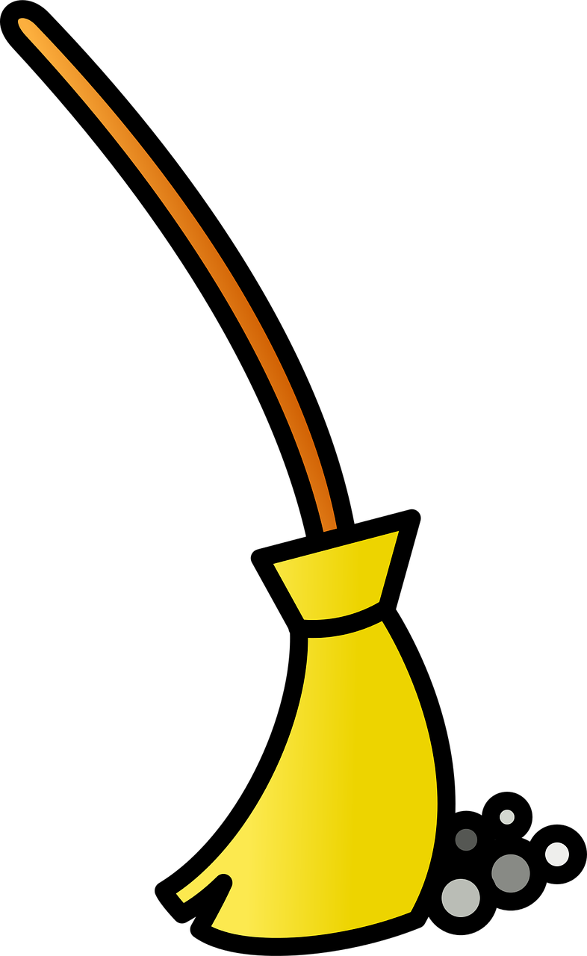 | broom
cr | 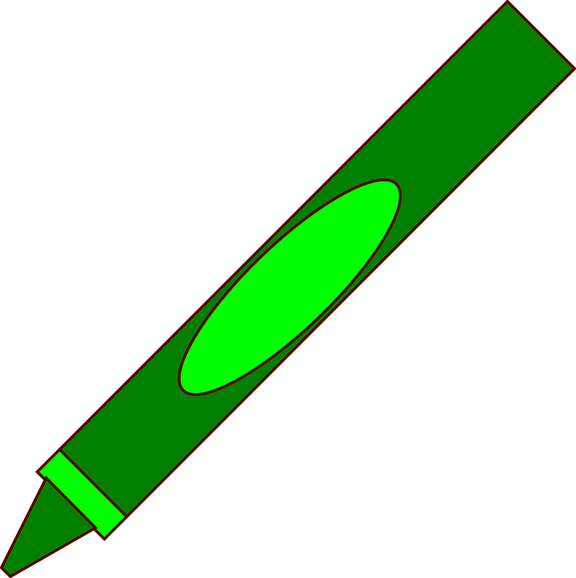 | crayon
dr | 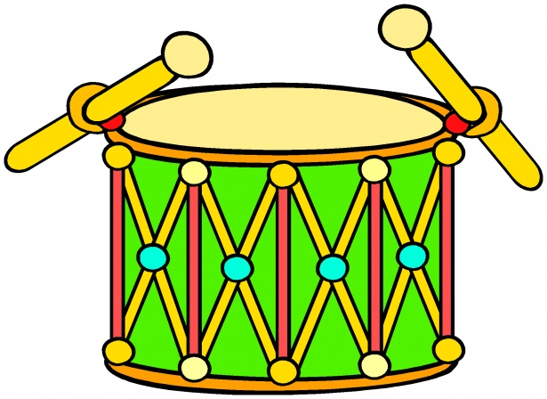 | drum
fr | 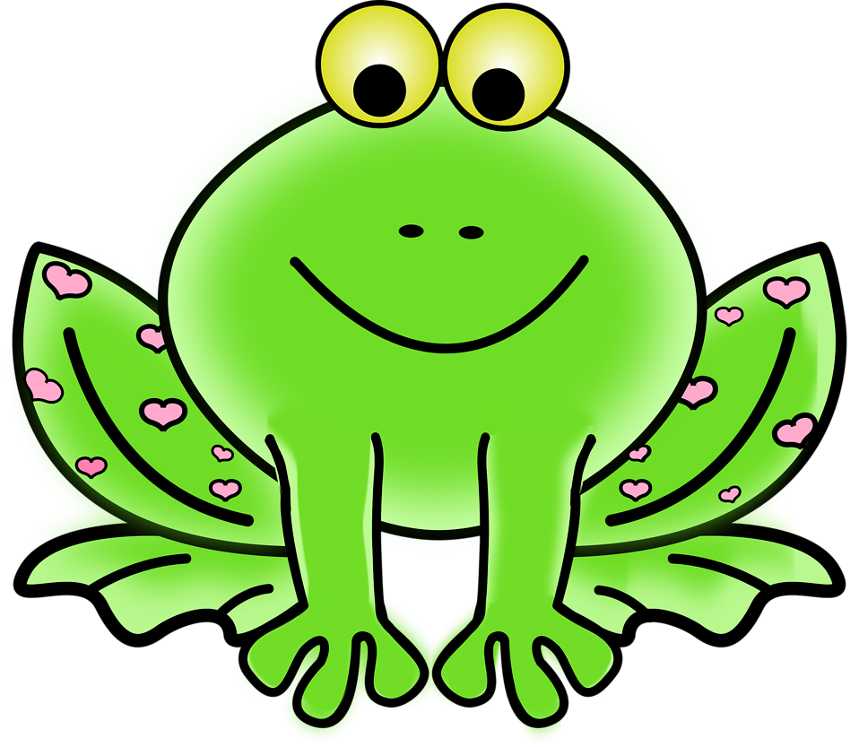 | frog
gr | 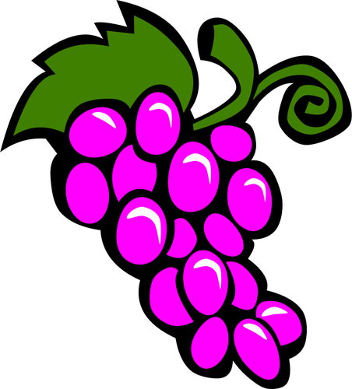 | grapes
tr | 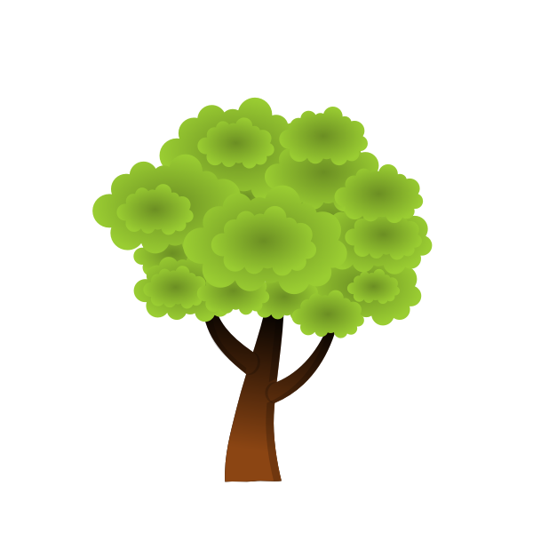 | tree
pr |  | prize

l-blends
bl | black
cl | clip
fl | flip
gl | glass
pl | plan
sl | slip

l-blends
bl | 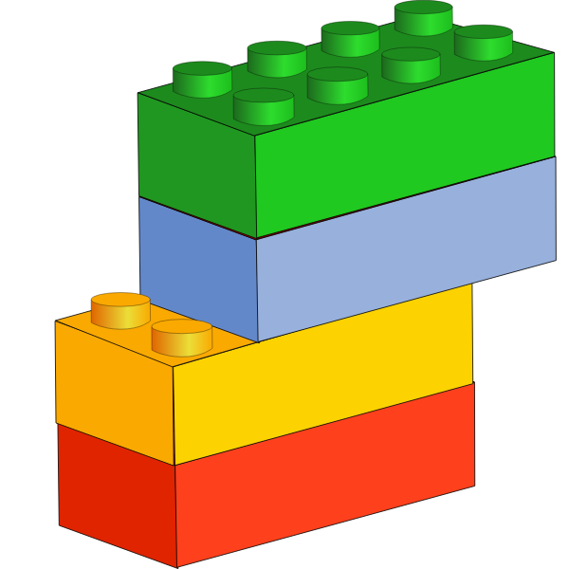 | blocks
cl | 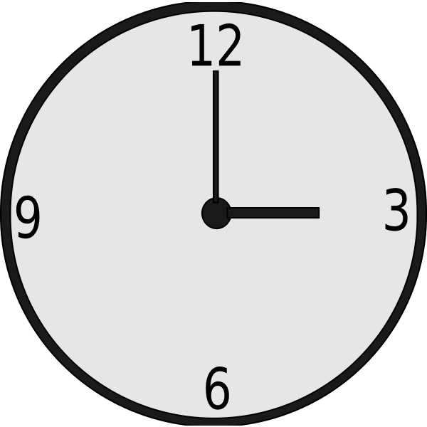 | clock
fl | 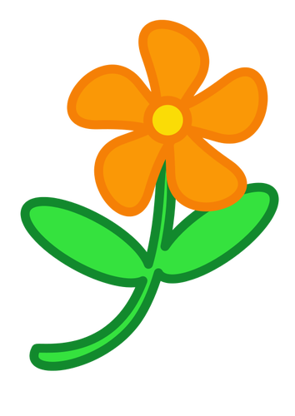 | flower
gl | 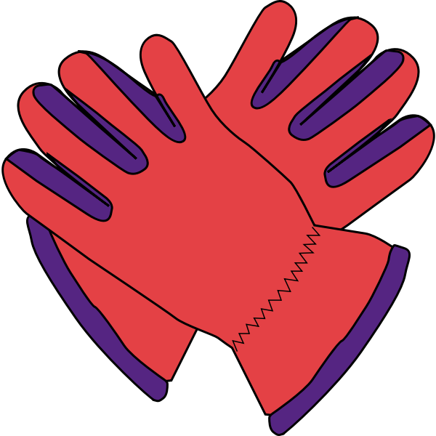 | gloves
pl | 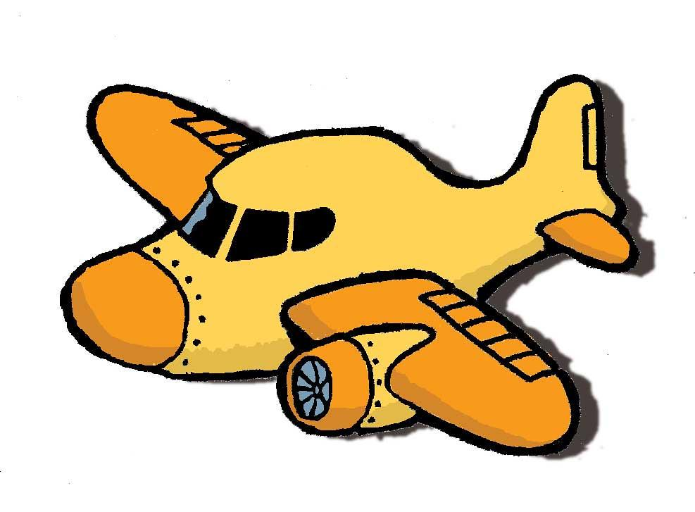 | plane
sl | 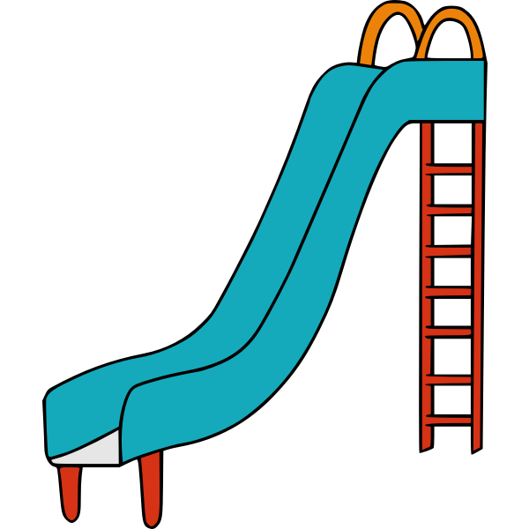 | slide

s-blends
sn | snap
sp | spot
sk | skip
st | stick
sm | smell
sw | swing

s-blends
sn | 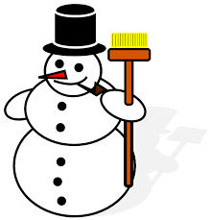 | snowman
sp | 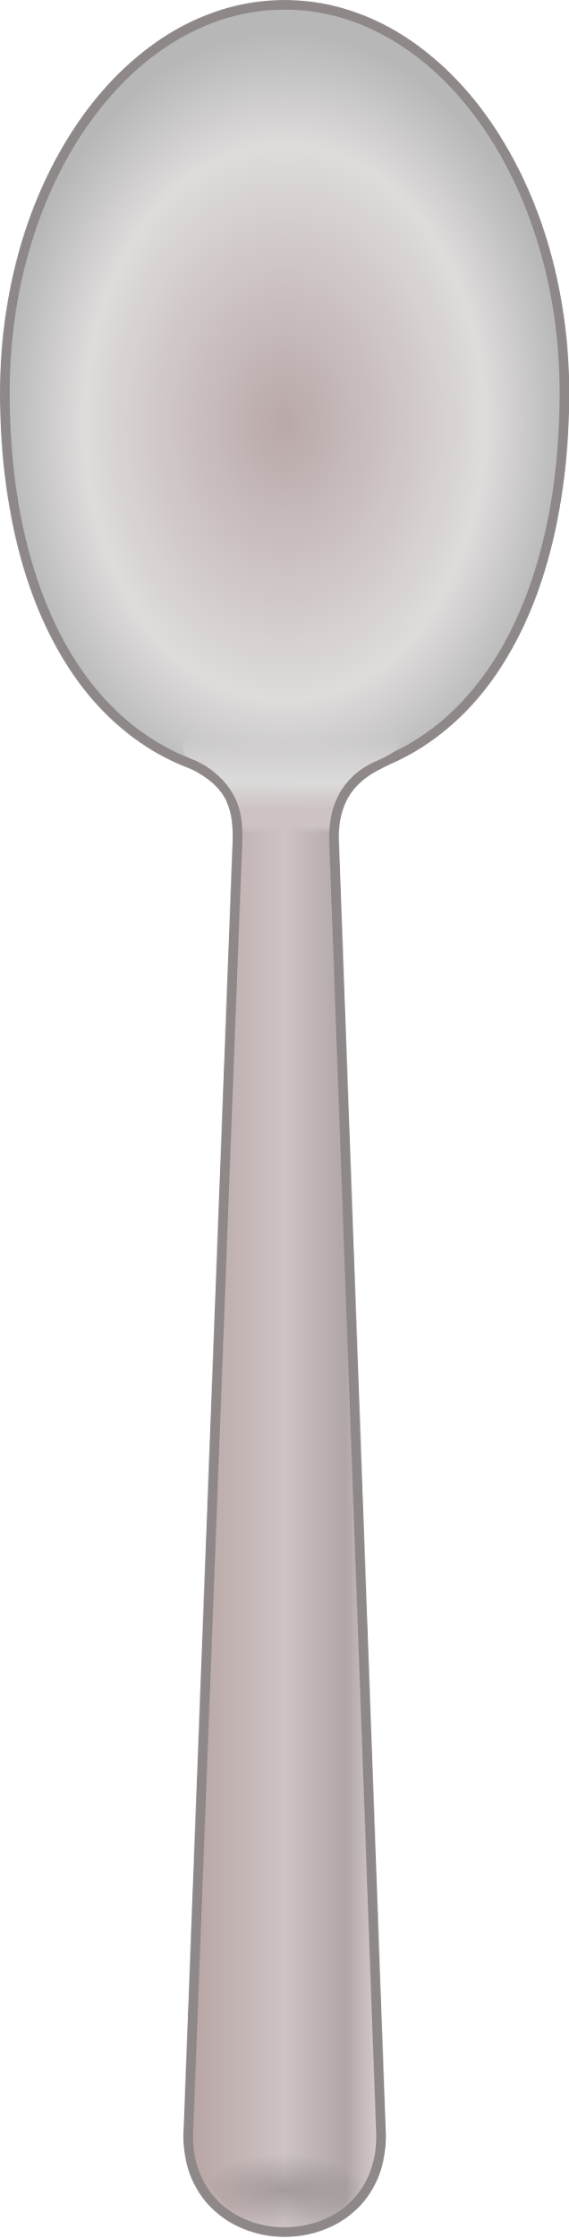 | spoon
sk | 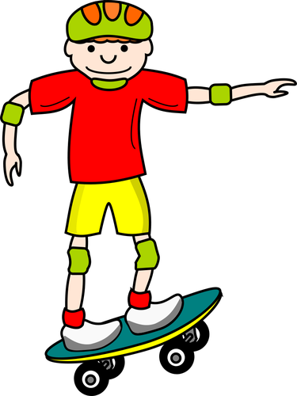 | skateboard
st |  | star
sm |  | smile
sw | 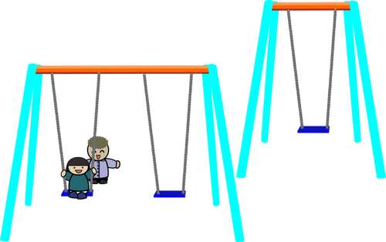 | swing
sc | 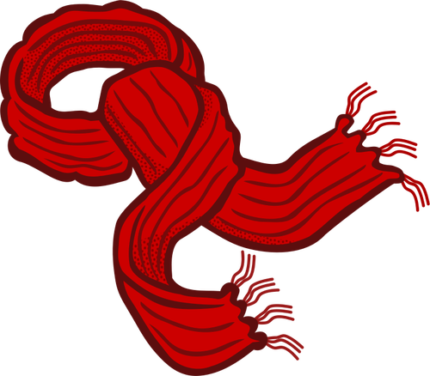 | scarf

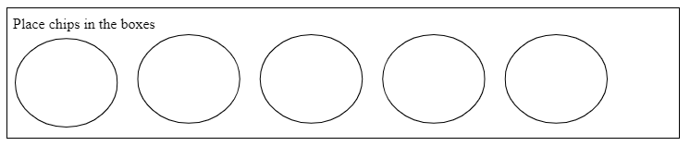

flat brat scat spat  blot spot trot slot plot  grit slit skit | flag brag drag snag  frog smog blog clog  snug smug | slip clip flip skip trip drip grip snip snap trap slap clap drop slop flop plop stop
flat | flag | slip | snap
brat | brag | clip | trap
blot | drag | flip | slap
spot | snag | skip | clap
trot | frog | trip | drop
slot | smog | grip | slop
grit | blog | snip | flop
skit | clog | drip | plop
slit | snug | plip | stop
 | slug

slip | lip | snap | nap
clip | lip | trap | rap
flip | lip | slap | lap
skip | kip | clap | lap
trip | rip | drop | rop
grip | rip | slop | lop
snip | nip | flop | lop
drip | rip | plop | lop
plip | lip | stop | top

slip | lip
clip | lip
flip | lip
skip | kip
trip | rip
grip | rip
snip | nip
drip | rip
plip | lip

snap | nap
trap | rap
slap | lap
clap | lap
drop | rop
slop | lop
flop | lop
plop | lop
stop | top

s-blend  sc- sm- st- sn- sp- sw- sk- | l-blend  bl- cl- fl- gl-  pl- sl- | r-blend  br- cr- dr- gr- pr- tr-

s-blend  sm- st- sn- sp- sw- sk- | l-blend  bl- cl- fl- gl- pl- sl- | r-blend  br- cr- dr- gr- pr- tr-

slam swam clam cram tram
swim trim skim slim

slid skid
grub club

READING
If you slip you will flop and go plop!

The clip had a grip on the bag of chips.

He will skip and then flip and we will clap.

Stop Mom so she will not trip on the trap and drop lunch.

A slug is a bug.
The sled is red.
The slab is hot. I slid on the top.
Did the mop slip?
Do not slam the lid.
The man is slim.
Do not slap the cat!
The slit is big.
The slot is not big.
Is Tim a slob?
Do not step in the pig slop
A drab crab bring the drum
drop the brick crush the drug
a crisp draft
Brad can drop the crab.
It was drab and crisp at the brunch
Drag the branch to the crib.
He was brash and the drum went crash.
I will drop my hat and crush the brim.

SPELLING:
Did Brad drop the crab?
We could have crisp bran.
I can drag the hat and crush the brim.
Do not slam the lid.
A slug is a bug
Did the mop slip?

Name: _______________________ Date: ____________________

1. | 2. | 3. | 4. ___, ____, ____,_____
5. | 6. | 7. | 8.

Name: ____________________________________ Date: _________________________________

Place chips & blocks in this box

Base Word | Ending

Name: __________________ Date: _____________

1. | 2. | 3. | 4. ___, ____, ____
5. | 6. | 7. | 8.

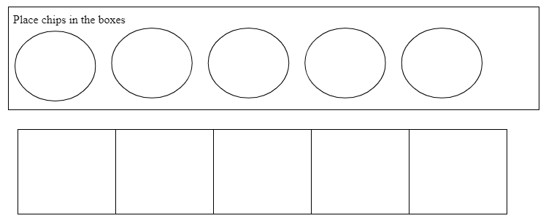

Dictation of Sounds

Dictation of Sentences

s-blends, l-blends, & r-blends

If you slip you will flop and go plop!

The clip had a grip on the bag of chips.

He will skip and then flip and we will clap.

Stop Mom so she will not trip on the trap and drop lunch.
s-blends & l-blends

The bag of chips had a clip on it.

If you slip you will flop and go plop!

He will skip and then flip and we will clap.

Stop to see the cats Snip and Snap play!

Lesson Blends l / s/ r Date:Spring 2023
Student(s): 3 - Grade Kind. Teacher: SJ
Orton Gillingham Lesson Planning Form
Phonograms/ Suffixes
Phonogram cards: t, a, l, g, o, d, e, ck, r, p, i, s, f (CAN SORT VOWELS & CONSONANTS → BUILD BLENDS)  R-blend card br brake cr cram dr drum fr fry gr grab pr prop tr trip  L- blend card bl black cl clip fl flop gl glass pl plan sl slip  S blends sn snap sp spot sk skip st stick sm smell sw swift | REVIEW THE CONCEPT OF CONSONANT BLENDS
Phonological Awareness / Phonemic Awareness
Model a couple of examples or more if students need the support:
If a visual is needed - 3 boxes with chipsw/ first space clear for bringing down chip  Say lap add c→ clap say rip add d→ drip say lip add s → slip  Say rip add g→ grip say top add s→ stop say nap add s→ snap  Hand out Phoneme-Grapheme Mapping sheet OR just chips  Which is it? s-blend / l-blend / r-blend ---> clip grip stop trap snap drop flop | FOR MORE REINFORCEMENT - HAVE THEM PUSH THE CHIPS BACK UP - SAYING THE SOUNDS - THEN THE WORD
Phonics- Reading words in isolation
Whiteboards: ALL WORDS ON ONE BOARD CHAINING → THEN READ WORDS AT THE END (can read all the words with NO blends ---READ ALL the words with BLENDS)  lip add s at the beginning → slip change the i to a slap change s to c → clap change the a to i → clip take away the k→ lip change l to r→ rip add g at the beginning → grip change the g to t→ trip change the t to d → drip → change the i to o → drop  Word Sort : Which is it? s-blend / l-blend / r-blend→ HIGHLIGHT THE BLEND AND SORT THE WORD  slip clip flip skip trip drip grip snip snap trap slap clap drop slop flop plop stop  ADD IF NEEDED → lip kp rip nip nap lap rop lop top CAN SORT BLENDS AND NO BLENDS)  Additional activities for follow up lessons:  Other sorts - by vowels or word families → have students write the words once they are sorted | Writing sort is  a good MULTISENSORY FOLLOW UP & DESK WORK
Reading of sentences in isolation
1. Sentences→find the words with blends - give each student a part of each sentence → HIGHLIGHT BLENDS
EACH CAN READ THEIR PHRASE - CAN DO THIS IN ORDER OF SENTENCE PARTS OR SCRAMBLED
If you slip you will flop and go plop!
The clip had a grip on the bag of chips.
He will skip and then flip and we will clap.
Stop Mom so she will not trip on the trap and drop lunch.
Guided Writing: Dictation of Sounds & / or Suffixes/Endings (Morphemes)
Follow SOS procedure - sort formation for the blends s blends l blends r blends What is the blend in
Dictation of Words & Sentences
Follow SOS procedure for spelling Words (5-7)
WRITING WORDS PHONEME-GRAPHEME mapping if needed or tapping:
Top stop; rip drip; lap clap; rap trap; lip flip; nap snap
OR
HIGHER LEVEL — Do a sort s blend —- l blend —- r blend
Stop. Slip. Trap
Snap. Flop. Drop
Sk may need cue Skip. Clap. Grip
Sentence Dictation (1-2)
We can snap and clap. Do not trip on the trap! If you slip you will go plop.
Can cue if need be—> there are 2 l blends or 2 r blends for the tricky ones
REMEMBER to dictate a section of the sentence at a time
END - GENERALIZE → Find the blends in the books you read - write them on 3 different sticky notes:)

