Lesson # Date:
Student(s): Teacher:
Decodable Book
Orton Gillingham Lesson Planning Form
Phonics Concept: short i vs. long pattern i-e (closed / silent-e)
Phonemic Awareness
Say words with ______ pattern
Students repeat the words with appropriate arm movements.
(prompt tapping the word if they need it to isolate a particular sound)
REVIEW short and long vowels - vc v-e
fin, hike mile, Sid, prize, his, Ike, drive, rid
Phonograms
Use phonogram cards
a, k, o, r, i-e, d, i, a-e,
Phonics: Reading of Words in isolation
Give a model first: Sort words, build words, or write words on the whiteboard.
They can also mark patterns if needed
PHONEME-GRAPHEME BOXES/ PAPER OR
fine, Sid, fin, rip, pine, ripe, pin, side
Phonics: Reading of Phrases or Sentences in isolation
did the slime
Tim’s ride is
hid the pipe
slid in slime
time to spin
the slim pine
Bill’s lime top
Dictation of Sounds & Words
/i, i-e, d, a-e, o, m/
SAMPLE: rid, pipe
lime, hid, pin, bike
Book Introduction
Pip can ride like Mike.
Get rid of the slime Tim!
Sid had a fine time on his bike.
Can you spin like Sid?
Hide the kite from his twin.
The fin on the kite made it spin.
Read the story/text -
(If needed: can note ahead of time on pages the pattern being taught.)
GAME

Lesson # Date:
Student(s): Teacher:
Decodable Book
Orton Gillingham Lesson Planning Form
Day 2
Phonemic Awareness
Say words with ______
Students repeat the words with appropriate arm movements.

Phonograms
Use phonogram cards.

Phonics
Sort, build or write words on the whiteboard. Practice reading words.

Guided Writing: Dictation of Sounds
Follow SOS procedure

Dictation of Words & Sentences
Follow SOS procedure for spelling
WRITING WORDS PHONEME-GRAPHEME BOXES/ PAPER
Words (10)

Sentence Dictation (2)

** If there is a specific non-phonetic SNAP word in the decodable that is needed to be practiced add in TCCA (Trace, Copy, Cover, Avert) either day is a great idea!

v
c
Closed Syllable


v
c
Silent-e Syllable
e

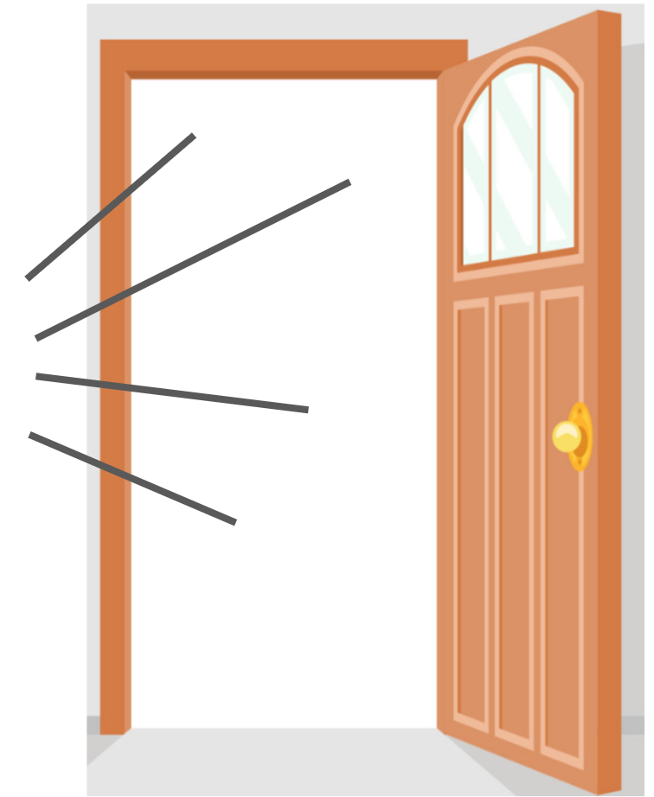
v
Open Syllable

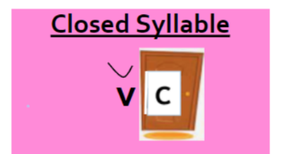


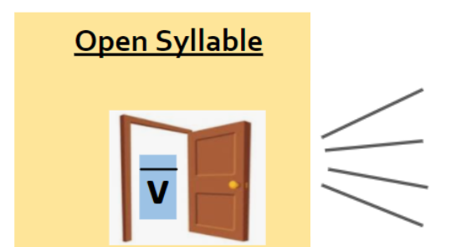

dim | dime
rid | ride
Tim | time
hid | hide
fin | fine
kit | kite
Sid | side
slim | slime
slid | slide
Pip | pipe
rip | ripe
pin | pine
Tim | time
twin | twine
spin | spine
grim | grime
grip | gripe
quit | quite

did the slime

Tim’s ride is

hid the pipe

slid in slime

time to spin

the slim pine

Bill’s lime top

Pip can ride like Mike.

Get rid of the slime Tim!

Sid had a fine time on his bike.

Can you spin like Sid?

Hide the kite from his twin.

The fin on the kite made it spin.

1.
 | v | v-e | vt | vt
2.
3.
 | v | v-e | vt | vt
4.
5.

Name: _______________________ Date: ____________________

Place chips in the boxes

Closed  v c | Silent-e  v - e

Name: _______________________ Date: ____________________

Sorting words from a list or a book.
Closed  v c | Silent-e  v - e

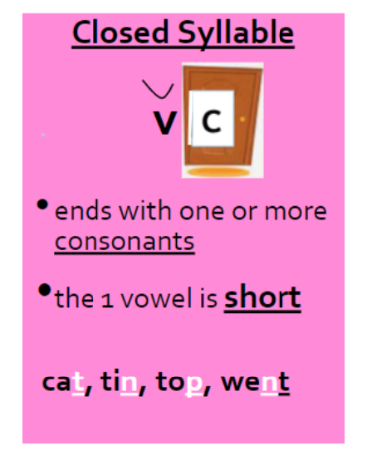
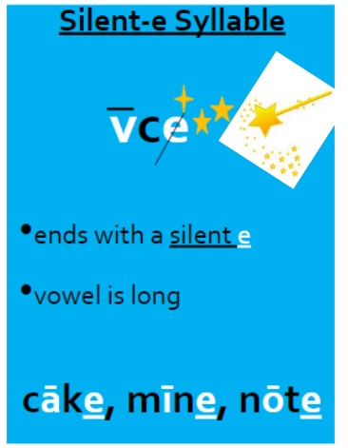

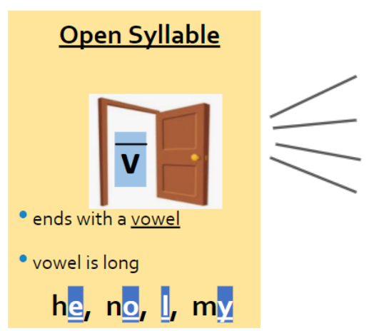

dim | dime
rid | ride
Tim | time
hid | hide
fin | fine
kit | kite
Sid | slide
slim | slime
slid | slide
Pip | pipe
rip | ripe
pin | pine
Tim | time
twin | twine
spin | spine
grim | grime
grip | gripe
quit | quite

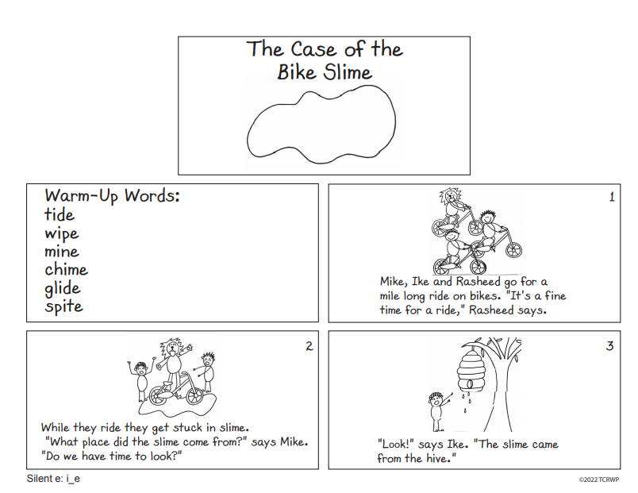

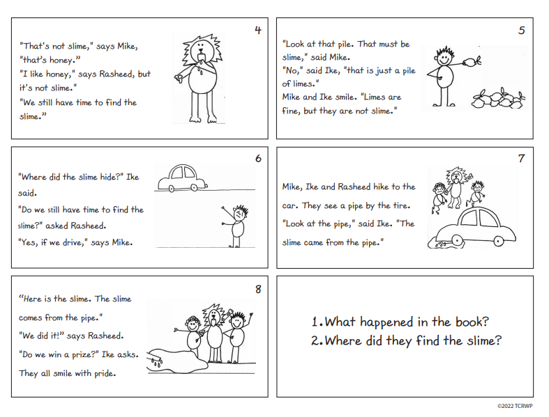

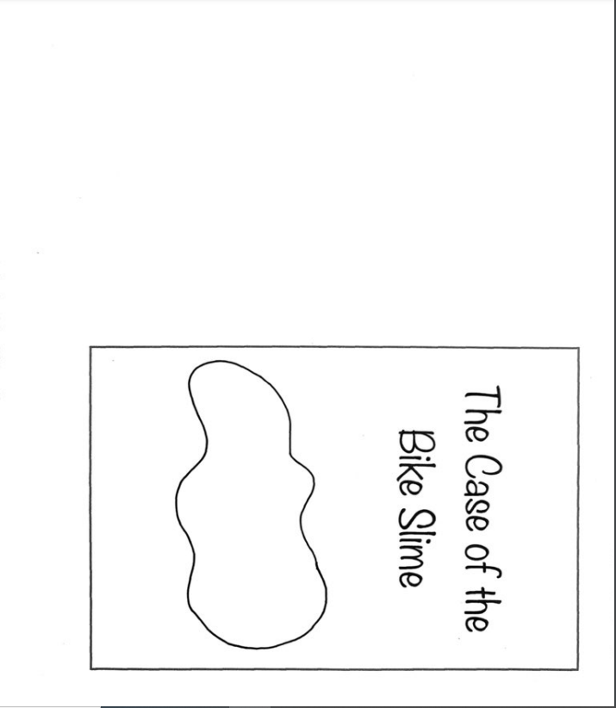

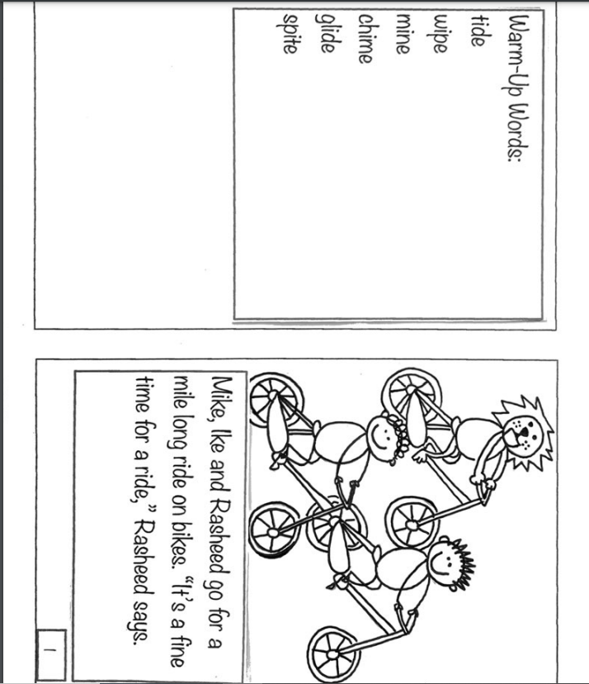

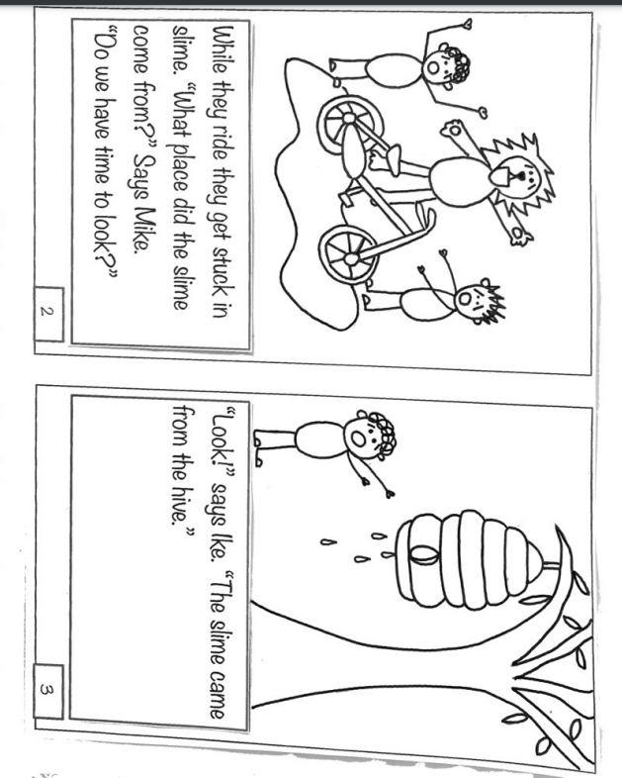

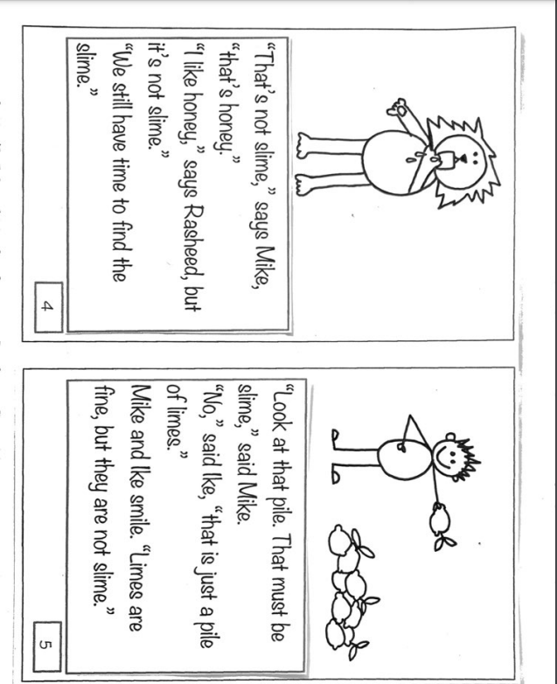

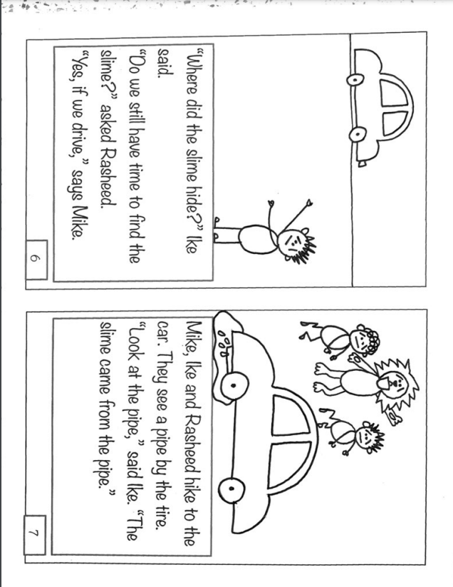

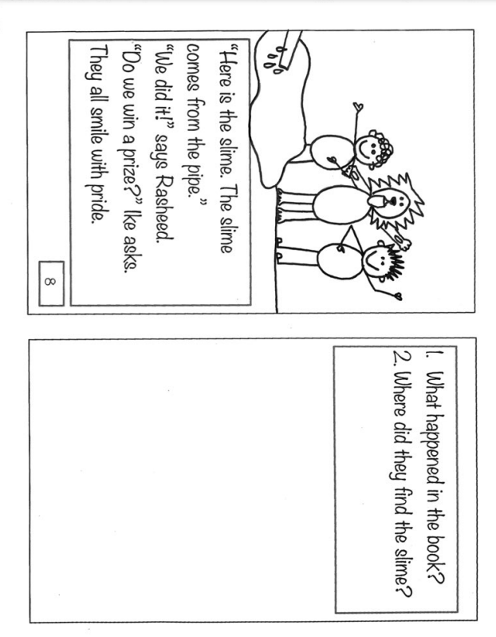

Name: _______________________ Date: ____________________

Place chips in this box

Name: _______________________ Date: _____________________

Place chips in this box

