Lesson Unchanging Bases w/ Simple Suffixes -ed, -ing, s, es Date:Spring 2023
Student(s): 3 - Grade 1 Teacher: SJ
Orton Gillingham Lesson Planning Form (Words & Sentences taken from A-Z books levels G H & I )
Phonograms/ Suffixes
Phonogram cards: b, a, i, ee, o, d, e, ck ,ay, ee, ea  Suffixes: -ing, -ed, -es, -s (-er) → (can put on red index cards or sticky notes)  How many letters in the ending -ing? -ed? -s? -es? (# letters = # blocks) | 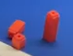
Phonological Awareness / Phonemic Awareness & Morphemic Awareness
Model a couple of examples or more if students need the support:
Hand out Phoneme-Grapheme/Suffix Mapping sheet  Phonological Awareness:  Say jumping - What is the base word? How do you spell the ending?  Phoneme -grapheme mapping with suffix  Can you show me jump say jump - pull down chips & say sounds J u m p &  How do you spell the ending? i n g (how many letters?) 3 letters= 3-blocks  PA: Say needed- What is the base word? How do you spell the ending?  PH -GR/ S: Can you show me need- say need - pull down chips saying the sounds &  How do you spell the ending? e d (how many letters?) 2 letters=2-blocks  PA: Say _______- What is the base word? How do you spell the ending?  PH -GR/S: Can you show me ____- say ____ - pull down chips saying the sounds &  How do you spell the ending? ___(how many letters?)  eating called (2 blocks -ed stand up to represent 1 sound) (others brushed played goats) | 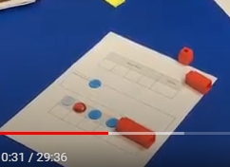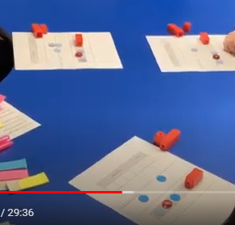
Phonics- Reading words in isolation
1. Handout sheet with endings/suffixes and review spelling and sounds again of each one.  -ing, -ed, -s, -es  2. Give each student words on a card or sticky note → students take turns reading their word with each ending - other students repeat the word & determine if it is a real word or not.  Model First: brushing (works), brushed (works), brushs (does not work), brushes (works)  Students’ words: need, wait, play, look, wash, jump, call, eat  Can have students write the words they make with the endings  Additional activities for follow-up lessons:  * A set of words each 1. Highlight the ending/suffix (cover it with a finger when reading)  2. Underline the base word  3. Read the word to yourself  * Together read and sort words according to ending - Orally create a sentence using words | 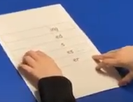  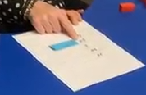
Reading of sentences in isolation
1. Sentences→find words with suffixes/endings:  Work on these together or give students a sentence each  - Highlight the ending/suffix (cover it with a finger when reading) ONE COLOR PINK  - Underline or box the base word YELLOW  - Read the words and sentences quietly  - Reading aloud taking turns in the group→ Identify the words with suffixes first in the sentence then read the sentence  Goat milk makes goat cheese.  They needed to find food.  Goats helped them in many ways.  Your dog needs to be played with.  Frogs have long legs for leaping.  They come in many shapes and sizes.  Your dog needs to be brushed and washed.  Fran and Fred looked down from their nest.  They waited for Fran and Fred to come back.  Goats spend most of their day playing and eating.  As pets, goats will come to you when you are calling their name.  They dig tunnels (tun- nels​) ​to make rooms for eating and sleeping. | 
Guided Writing: Dictation of Sounds & / or Suffixes/Endings (Morphemes)
Follow SOS procedure
/d/ (d, ed) /t/ (t, -ed) /id/ (-ed) /ing/ (-ing) /s/ (-s) /es/ (-es)
Dictation of Words & Sentences
Follow SOS procedure for spelling
Words (5-7)
WRITING WORDS PHONEME-GRAPHEME & SUFFIXES BOXES/ PAPER
jumped looking needed eats played waiting brushes

CAN Add in irregular snap words e.g.: wants - wanted - wanting

Sentence Dictation (1-2)
1. The dog needed to be brushed.
2. She waited and helped with the goats.
3. Create your own sentence using and -ed or -ing ending

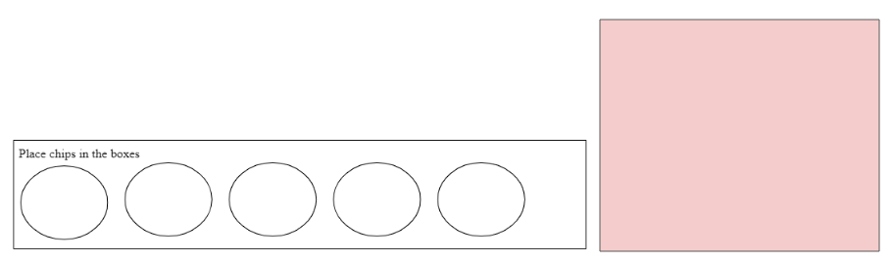

Base Word |  |  |  | Ending

need | wait | play
look | wash | jump
call | eat | brush

ing
ed …
s
es (s, sh, ch, x)
er
ly
y

-ed
/id/ | /d/ | /t/

-ing | -ed | -s | -es

Goat milk makes goat cheese.

They needed to find food.

Goats help us in many ways.

Your dog needs to be played with.

Frogs have long legs for leaping.

They come in many shapes and sizes.

Your dog needs to be brushed and washed.

Fran and Fred looked down from their nest.

They waited for Fran and Fred to come back.

Goats spend most of their day playing and eating.

As pets, goats will come to you when you are calling their name.

They dig tunnels (tun- nels​) ​to make rooms for eating and sleeping.

Name: _______________________ Date: _____________________

1. | 2. | 3. | 4. ___, ____, ____
5. | 6. | 7. | 8.

Base Word |  |  |  | Ending

Base Word |  |  |  | Ending

