Lesson Unchanging Bases w/ Simple Suffixe -ed Date: 2023
Student(s): Small group Grade 1 & 2 Teacher: SJ

Phonograms/ Suffixes
Phonogram cards: b, a, i, ee, o, d, e, ck ,ay, ee, ea  Suffixes: -ing, -ed, -es, -s (-er) → (can put on red index cards or sticky notes)  How many letters in the ending -ing? -ed? -s? -es? (# letters = # blocks)  Check in to see if students understand base word / suffix or ending  If not give examples before moving on - can use other endings if that is easier for them  jumping jumps jumped wanted wants sailed sailing sails | 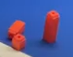
Phonological Awareness / Phonemic Awareness & Morphemic Awareness
Model a couple of examples or more if students need the support:
CAN START WITH CHECKING IN WITH THE STUDENTS ABOUT THE SOUNDS THEY HEAR AT THE END OF THE WORD → /ID, D, OR T/  CHECK IN WITH STUDENTS ABOUT THE MEANING OF -ED  Hand out Phoneme-Grapheme/Suffix Mapping sheet  Phonological Awareness:  Say landed- What is the base word? How do you spell the ending?  Phoneme-grapheme mapping with suffix-(MODEL 2 blocks -ed stand up to represent 1 sound)  Can you show me land say land - pull down chips & say sounds l a n d &  How do you spell the ending? ed (how many letters?) 2 letters= 2-blocks  PA: Say jumped- What is the base word? How do you spell the ending?  PH -GR/ S: Can you show me need- say need - pull down chips saying the sounds &  How do you spell the ending? e d (how many letters?) 2 letters=2-blocks  PA: Say _______- What is the base word? How do you spell the ending?  PH -GR/S: Can you show me ____- say ____ - pull down chips saying the sounds &  How do you spell the ending? ___ How many letters?  jumped called lasted brushed played dented watched waited | 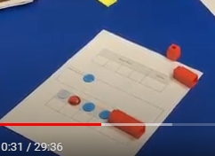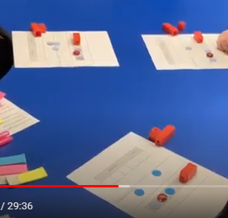
Phonics- Reading words in isolation
Hand out -ed words to each student - at least a word with each sound /id, d, t/
Ask them to
- Circle/highlight the ending in the words jumped
- Underline the base word
- Have them read the base word first (cover the ending) & then read the word w/ -ed ending
- Then students decide & sort if it is the
/id/ /d/ or /t/ sound EXPLAIN THE / / = SOUNDS LIKE (LIKE 2 BIG EARS)
- Next have the students read down the lists and then read across the list to build fluency -
Reading together first if needed or take turns

landed lasted waited dented needed painted rented greeted wanted
called played sailed filled stayed showed rained peeled roamed
washed brushed walked watched looked jumped helped crushed leaked

Reading of sentences in isolation
1. Sentences→find words with suffixes/endings:  Work on these together or give students a sentence each  - Highlight the ending/suffix (cover it with a finger when reading) ONE COLOR PINK  - Underline or box the base word YELLOW  - Read the words and sentences quietly  - Reading aloud taking turns in the group→ Identify the words with suffixes first in the sentence then read the sentence  They needed to find food.  Dogs helped them in many ways.  He played with his dog all the time.  Fran and Fred looked down from their nest.  They waited for Fran and Fred to come back.  The dogs played all day long.  He called the dog’s name and it came to him.  His dog needed to be brushed and washed before going inside.  The people waited and watched for Fran and Fred, to see if they landed back to the nest. | 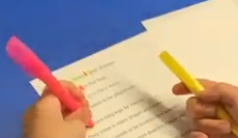
Guided Writing: Dictation of Sounds & / or Suffixes/Endings (Morphemes)
Follow SOS procedure Endings
/d/ (d, ed) /t/ (t, -ed) /id/ (-ed) /ing/ (-ing) /s/ (-s) /es/ (-es)
Dictation of Words & Sentences
Follow SOS procedure for spelling Words (5-7)
WRITING WORDS PHONEME-GRAPHEME & SUFFIXES BOXES/ PAPER

jumped dented played needed looked helped brushed landed lifted waited

Sentence Dictation (1-2)
1. The dog needed to be brushed.
2. She played and helped with the dogs.
3. Create your own sentence using and -ed ending
Orton Gillingham Lesson Planning Form (Words & Sentences taken from A-Z books levels G H & I )
CAN Add in irregular snap words e.g.: wanted

Follow up lessons can include this activity with mixed endings
1. Handout sheet with endings/suffixes and review spelling and sounds again of each one.  -ing, -ed, -s, -es  2. Give each student words on a card or sticky note → students take turns reading their word with each ending - other students repeat the word & determine if it is a real word or not.  Model First: brushing (works), brushed (works), brushs (does not work), brushes (works)  Students’ words: need, wait, play, look, wash, jump, call, eat  Can have students write the words they make with the endings  Additional activities for follow-up lessons:  * A set of words each 1. Highlight the ending/suffix (cover it with a finger when reading)  2. Underline the base word  3. Read the word to yourself  * Together read and sort words according to ending - Orally create a sentence using words | 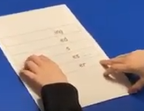  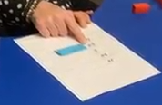

Unchanging Bases w/ Simple Suffixes -ed
b, a, i, ee, o, d, e, ck ,ay, ee, ea -ing, -ed, -es, -s (-er) (# letters = # blocks)
base word / suffix or ending jumping jumps jumped wanted wants sailed sailing sails
Phonological Awareness / Phonemic Awareness & Morphemic Awareness
HEAR AT THE END OF THE WORD → /ID, D, OR T/ & MEANING OF -ED

Say landed- What is the base word? How do you spell the ending?

Can you show me land say land - pull down chips & say sounds l a n d &
How do you spell the ending? ed (how many letters?) 2 letters= 2-blocks

needed jumped called lasted brushed played dented watched waited
Phonics- Reading words in isolation
Circle/highlight the ending jumped- Underline the base word
read the base word first (cover the ending) & then read the word w/ -ed ending
Then students decide & sort if it is the /id/ /d/ or /t/ sound EXPLAIN THE / / = SOUNDS LIKE (LIKE 2 BIG EARS)
read down the lists and then read across the list to build fluency - Reading together first if needed or take turns

landed lasted waited dented needed painted rented greeted wanted
called played sailed filled stayed showed rained peeled roamed
washed brushed walked watched looked jumped helped crushed leaked
Reading of sentences in isolation
Sentences→find words with suffixes/endings:
Work on these together or give students a sentence each
Highlight ending Underline or box the base word -Read the words and sentences quietly
Reading aloud taking turns in the group→ Identify the words with suffixes first in the sentence then read the sentence
They needed to find food.
Dogs helped them in many ways.
He played with his dog all the time.
Fran and Fred looked down from their nest.
They waited for Fran and Fred to come back.
The dogs played all day long.
He called the dog’s name and it came to him.
His dog needed to be brushed and washed before going inside.
The people waited and watched for Fran and Fred, to see if they landed back to the nest.
Guided Writing: Dictation of Sounds & / or Suffixes/Endings (Morphemes)
Follow SOS procedure Endings
/d/ (d, ed) /t/ (t, -ed) /id/ (-ed) /ing/ (-ing) /s/ (-s) /es/ (-es)
Dictation of Words & Sentences
Follow SOS procedure for spelling Words (5-7)
jumped dented played needed looked helped brushed landed lifted waited

Sentence Dictation (1-2)
1. The dog needed to be brushed.
2. She played and helped with the dogs.
3. Create your own sentence using and -ed ending

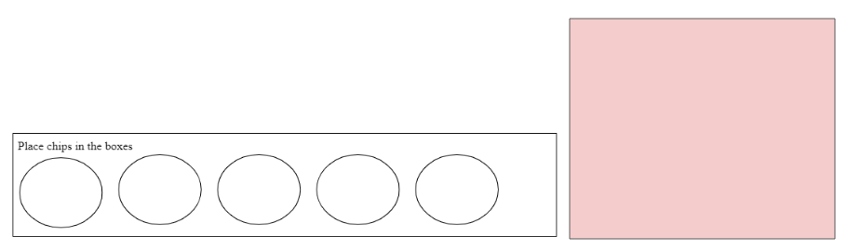

Base Word |  |  |  | Ending

needed | sailed | looked
waited | filled | jumped
landed | played | brushed
dented | called | walked
lasted | stayed | watched
painted | showed | helped
wanted | rained | washed
greeted | peeled | crushed
rented | roamed | leaked

-ed
/id/ | /d/ | /t/

They needed to find food.
Dogs helped them in many ways.
He played with his dog all the time.
Fran and Fred looked down from their nest.
They waited for Fran and Fred to come back.
The dogs played all day long.
He called the dog’s name and it came to him.
His dog needed to be brushed and washed before going inside.
The people waited and watched for Fran and Fred to see if they landed back in the nest.

His dog needed
to be brushed and
washed before going inside.

The people waited and
watched for Fran and Fred
to see if they landed back in the nest.
Scroll down for more :)
Name: _______________________ Date: _____________________

1. | 2. | 3. | 4.
5. | 6. | 7. | 8.

Base Word |  |  |  | Ending

Base Word |  |  |  | Ending

ing
ed …
s
es (s, sh, ch, x)
er
ly
y

-ing | -ed | -s | -es

Goat milk makes goat cheese.

They needed to find food.

Goats help us in many ways.

Your dog needs to be played with.

Frogs have long legs for leaping.

They come in many shapes and sizes.

Your dog needs to be brushed and washed.

Fran and Fred looked down from their nest.

They waited for Fran and Fred to come back.

Goats spend most of their day playing and eating.

As pets, goats will come to you when you are calling their name.

They dig tunnels (tun- nels​) ​to make rooms for eating and sleeping.

