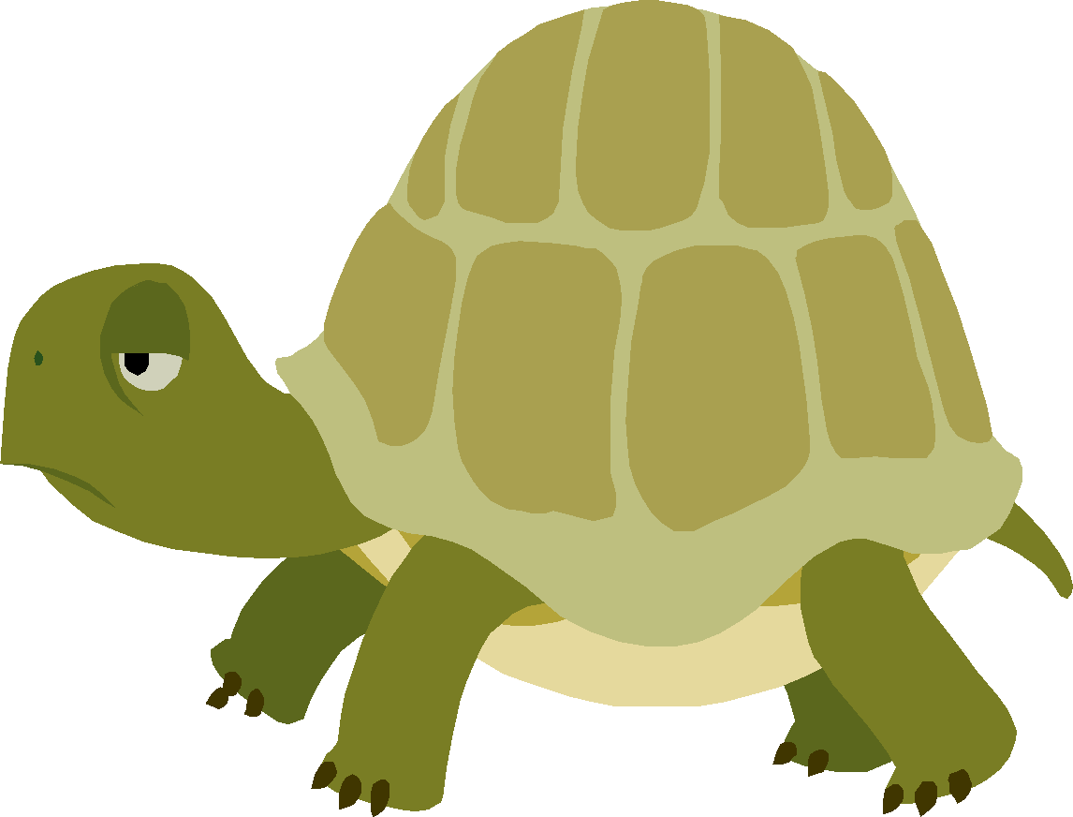

- Do you see ----CLE at the end of the word?
- Count back three
- Divide the word with a line
- Read the syllables, read the word
--cle
3 2 1
turtle

