a | ir | c | ar | u
qu | o | ur | i | e

-ble | stable
-dle | saddle
-fle | rifle
-gle | bugle
-kle | pickle
-ple | simple
-tle | bottle
-zle | puzzle

par | o | in | po
cab | hip | snip | ver

READ & SORT SYLLABLES
Open | Closed | Vowel-r

How many words can you make out of the detached syllables?

Apply syllable division rules to the words above. What syllable division rule do they follow?
Rabbit | Tiger | Robin

an | rum | gar | sta
jun | fum | tem | cir
Add a consonant -le 2nd syllable to make a word

mar | fa | bu | sim
strug | no | fid | hum
Add a consonant -le 2nd syllable to make a word

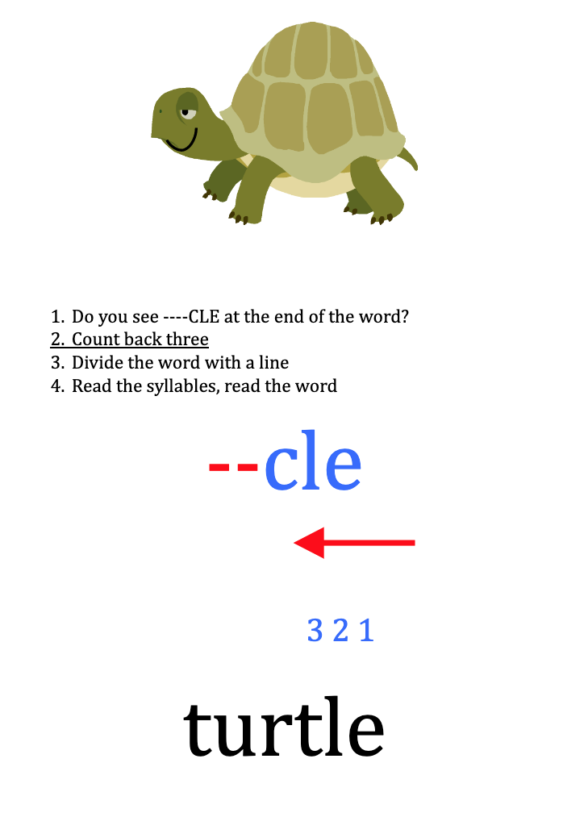

maple | ruffle | grumble
thimble | title | ladle
fable | dangle | puzzle
battle | gargle | candle
temple | uncle | gobble
fumble | noble | trample
staple | crumple | sizzle
uncle | circle | able
twiddle | hobble | mingle
nozzle | angle | dimple
stifle | idle | garble
brittle | kindle | ogle

Name:_____________________ Date:_____________

sim | gle |  | sta | dle
jun | ple |  | fid | ble
bu | tle |  | sim | ble
ti | ble |  | hum | ple
mar | gle |  | sta | ble

Consonant le words = -cle
open  1st syllable | closed  1st syllable | Vowel-r1st syllable
bible | bubble | turtle

Name: _________________ Date:________

driz | ple |  | gar | ble
sim | gle |  | sta | dle
sta | ple |  | fid | gle
jun | ble |  | cir | ble
tem | ble |  | hum | fle
mar | gle |  | sti | gle
bu | zle |  | strug | cle

Consonant le words = -cle
open  1st syllable | closed  1st syllable | Vowel-r  1st syllable
bible | bubble | turtle

sem | ble | re
gle | tan | rec
ple | ex | am

apple | aple
woble | wobble
shutle | shuttle
little | litle
cabble | cable
snifle | sniffle
tabble | table
fizzle | fizle
bugle | buggle
batle | battle
fabble | fable
wigle | wiggle
pebble | peble

hagle | haggle
idle | iddle
muzzle | muzle
ridle | riddle
staple | stapple
laddle | ladle
nible | nibble
bugle | buggle
struggle | strugle
medle | meddle
quible | quibble
scrible | scribble
abble | able

Name__________________________ Date:_________________

1. | 2. | 3. | 4.
5. | 6. | 7. | 8.

Consonant -le Words
1st syllable / -le

1. ________/ __ __ __ ____________________

2. ________/ __ __ __ _____________________

3. ________/ __ __ __ _____________________

4. ________/ __ __ __ _____________________

5. ________/ __ __ __ ______________________

1st syllable | Open | Closed | Vowel-r
ex | title | bubble | gargle
6.
7.
8.
9.
10.

