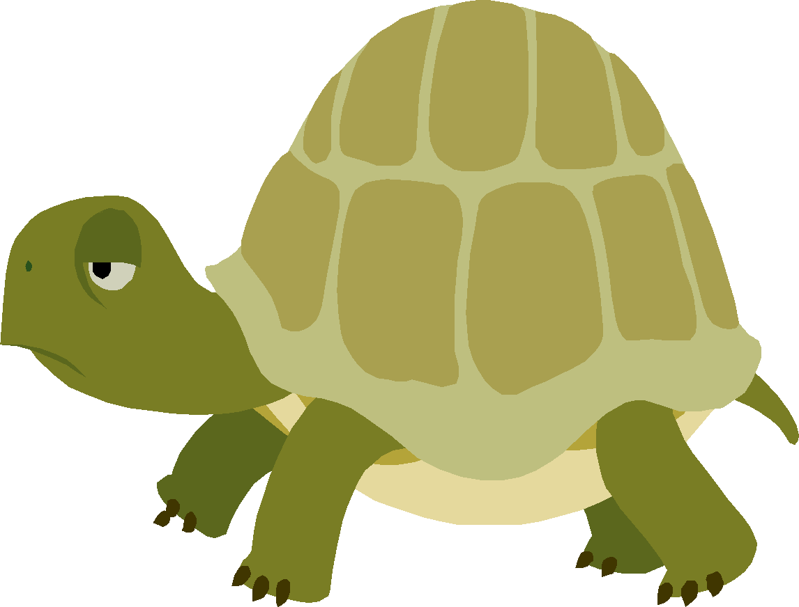
- Do you see ----CLE at the end of the word?
- Count back three
- Divide the word with a line
- Read the syllables, read the word tur/tle

/321  tur/tle | tur | tle
able
bridle
title
bugle

cable

cradle

cycle

fable

idle

maple

1. Do you see ----CLE at the end of the word?
2.Count back three
3. Divide the word with a line
4. Read the syllables, read the word tur/tle

/321  tur/tle | tur | tle
measles
needle
noble
people
poodle
stable
stifle
table
trifle
eagle
gable
rifle
noodle

1. Do you see ----CLE at the end of the word?
2.Count back three
3. Divide the word with a line
4.Read the syllables, read the word tur/tle

/321  tur/tle | tur | tle

1. Do you see ----CLE at the end of the word?
2.Count back three
3. Divide the word with a line
4.Read the syllables, read the word tur/tle

/321  tur/tle | tur | tle

1. Do you see ----CLE at the end of the word?
2.Count back three
3. Divide the word with a line
4.Read the syllables, read the word tur/tle

/321  tur/tle | tur | tle

