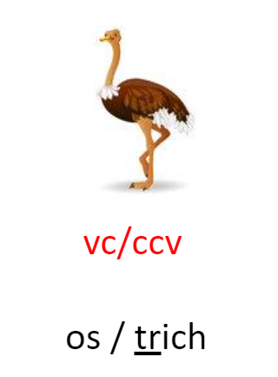

monster | stampede | athlete
pumpkin | bathmat | sunshade

