Is it ou or ow?
Use ou (loud), or ow (cow), to complete the words.

 |  | 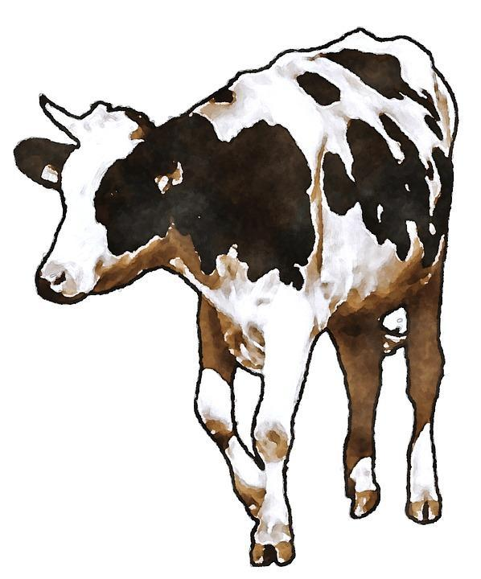
p_____
cl____d
sn____t
ch____
br____
c____nt
pl____
bl____se
sc____
m____nt

