PHONEME MAPPING

/theme/



/skate/



/dime/



/fix/



/quote/



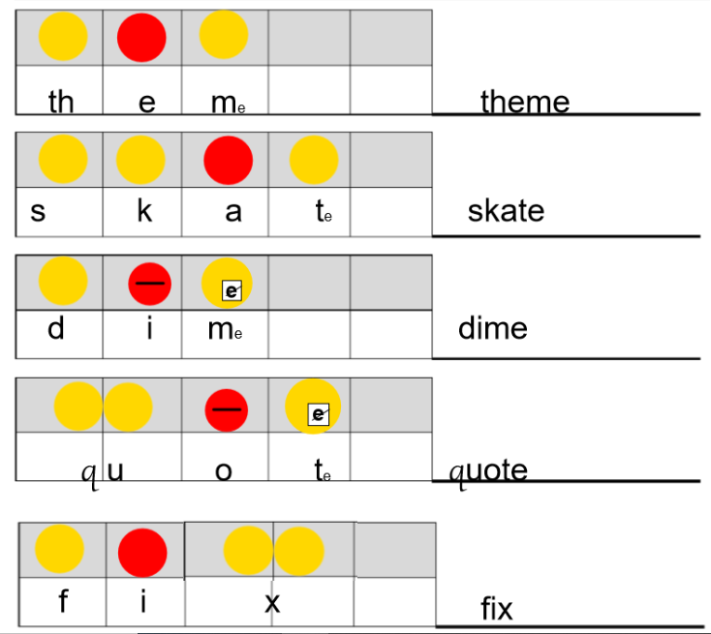

Name:

Name:

