Phoneme Mapping
/cat/

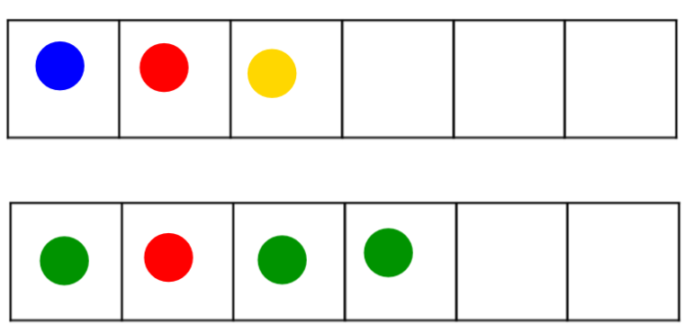
- Always use one sound/ one phoneme per box.

- Use ONE consistent color for the vowel (red or pink), one or varied colors can be used for consonants. It is the 💓 HEART of the word. (Every word has a vowel)

- Students have grid paper and chips. In large groups, teachers can use a document camera, grid paper, and chips, or an interactive smartboard with a phoneme sheet.

- Say the word and have the student repeat the word and then say the sounds as they pull down chips for the number of sounds in a word.

- Prompts can include
What sounds do you hear?

- Tricky patterns: (samples next page)
digraphs & trigraphs (one box)
blends & tri-blends (two & three boxes)
qu /kw/ (two boxes, close together)
x /ks/ (two boxes)

“theme”



“skate”



“dime” Can contrast →
“dim”
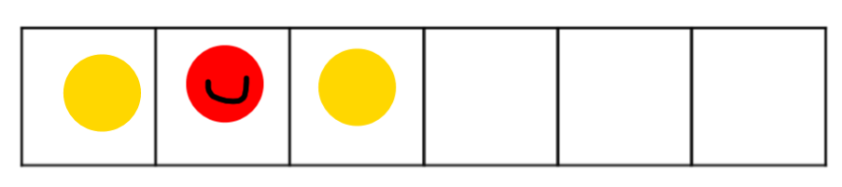

“fix”



“quote”



multi-syllable words - skip a space



