DAY 1 Lesson # Date:_____________
Objective | Being word detectives, discover what ________________is and identify __________________.
Visual  Phonograms Cards:  Sound -Symbol  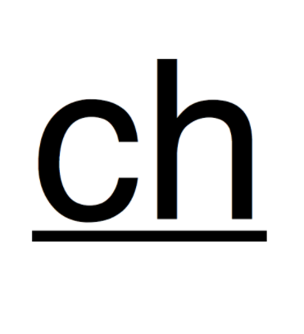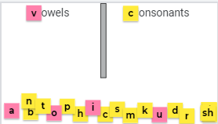 | When I call you, come up, choose a letter,  [say the letter name]  [say the keyword]  say its sound, and sort it, telling us if it is a vowel or consonant. Do an example.  You can direct all students to use 2 fingers to write out the chosen letter on the table or carpet while repeating the sound
Auditory  Phonological Awareness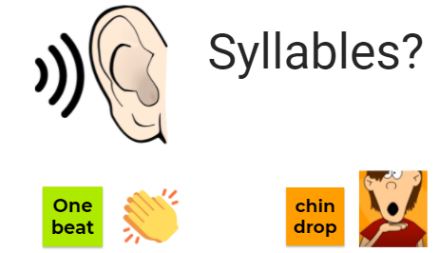 | What is a syllable? (Beat in a word /chin drop/part of a word)  Now you are going to repeat the word & full-body tap - head - hips - knees- toes for the number of syllables in the word - remember first repeat the word “ ???” and tap:  (Do a couple together as needed)  5-7 Words
Auditory  Phonemic Awareness  Can be Auditory Discovery  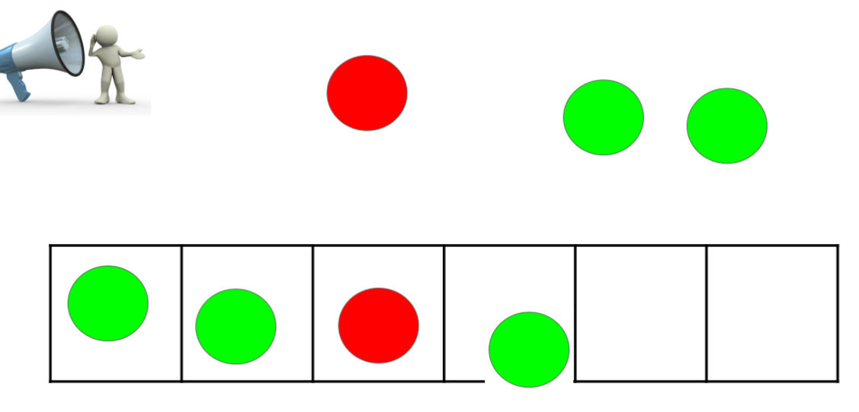 | Listen to the word and pull down a chip for each sound in the word - use a red chip for the vowel sound & green chips for the consonants.  Here is an example: / z i p/ → pulling-down a chip for each sound→ “zip”  Call students to the board to do a few examples; the rest of the students can do it on their own PH-GR maps, by tapping fingers or tapping on arms.  5-10 Words  What do you notice about these words and their sounds?  Where do you hear the vowel sound? (If needed prompt beginning - middle or end)
Visual/Kinesthetic  NEW SKILL/CONCEPT  VISUAL DISCOVERY or TCCA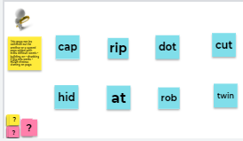 | Let’s read the words aloud (take turns or together)  5-10 Words  What do you notice about the words? Reinforce the targeted skills/ concept  Have students be interactive with sorts or labeling  ON THE NEXT PAGE  Repeat the critical observations to explicitly state what is discovered or worked on
Visual  Reading in context  Phrases/ Sentences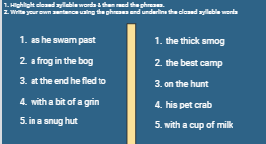 | 5-10 Phrases/Sentences  - Have students highlight closed syllable words in the phrases  - Read the phrases aloud  - Have students write two to three sentences using the phrases.
Auditory-Kinesthetic  Focus on SPELLING  Sounds-Words 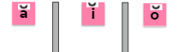 | Sounds - Words  Choose words appropriate for your group or class.  Aiming for success → what do students need to be 80% or more successful?

DAY 2 Lesson #2 Date:________________
NEW Lesson Skill or Concept/Objective | Being word detectives, discover what a closed syllable is and identify  closed syllables in words.
Auditory  Phonemic Awareness | Listen to the word and pull down a chip for each sound in the word - use a red chip for the vowel sound.  Here is an example: / z i p/ → pulling-down a chip for each sound→ “zip”  Call students to the board to do a few examples; the rest of the students can do it on their own PH-GR maps, by tapping fingers or tapping on arms.  tub, sit, spot, last, ship  Where do you hear the-------- sound? (If needed prompt e.g., beginning - middle or end)
Visual  Phonograms Cards:  Sound -Symbol | When I call you, come up, choose a letter, say its sound, and sort it telling us if it is a vowel or consonant. Do an example.  You can direct all students to use 2 fingers to write out the chosen letter on the table or carpet while repeating the sound
Auditory/Visual  WORD BUILDING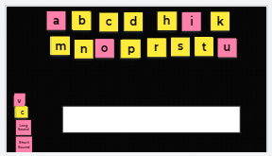  Students use whiteboards or magnetic letters (boards) | 1. Find these sounds to make a word /? / /?/ /?/ saying it with time between sounds so that students can blend sounds together.  2. Change the /d/ to /t/ - everyone repeat /?/ to /?/ [Prompt if needed, what are we changing?]  Students repeat “/?/ to /?/”  3. Choose a student to blend the new sounds & read the new word.  What is the new word ??? (???)  Change /_/ to /_/ (____) change /_/ to /_/ (___) change /_/ to /_/ (____)  Change /_/ to /_/ (____) change /_/ to /_/ (___)
VisualReading words in isolation | REVIEW RULECONCEPT / SKILL W/ A DIFFERENT SET OF WORDS  Let’s read the words aloud (take turns or them together)  5-10 WORDS  What do you notice about the words?  Reinforce students feedback and label - BE INTERACTIVE  ON THE NEXT PAGE  explicitly state what THE RULE/ SKILL OR CONCEPT IS  “A ________________”
Visual  Reading in context  Phrases/ Sentences | 5-10 Phrases / Sentences  - Have students highlight closed syllable words in the phrases  - Read the phrases aloud  - Have students write two to three sentences using the phrases.
Auditory-Kinesthetic  Focus on SPELLING  Words & Sentences | Choose words appropriate for your group or class.
Visual STORY:

