DAY 1 NEW Lesson # Date:_____________
Objective | Being word detectives, discover what ________________is and identify __________________.
Visual
Phonograms Cards:
Sound -Symbol
10-15 phonograms/morphemes
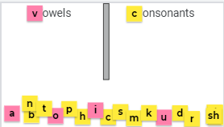
Auditory
Phonological Awareness
5-7 Words 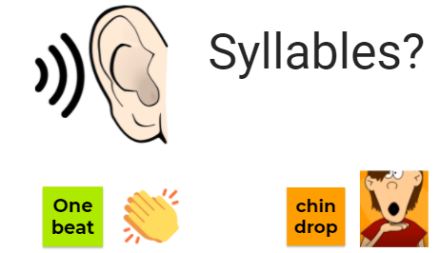 or
Auditory
Phonemic Awareness
5-10 Words

Can be Auditory Discovery
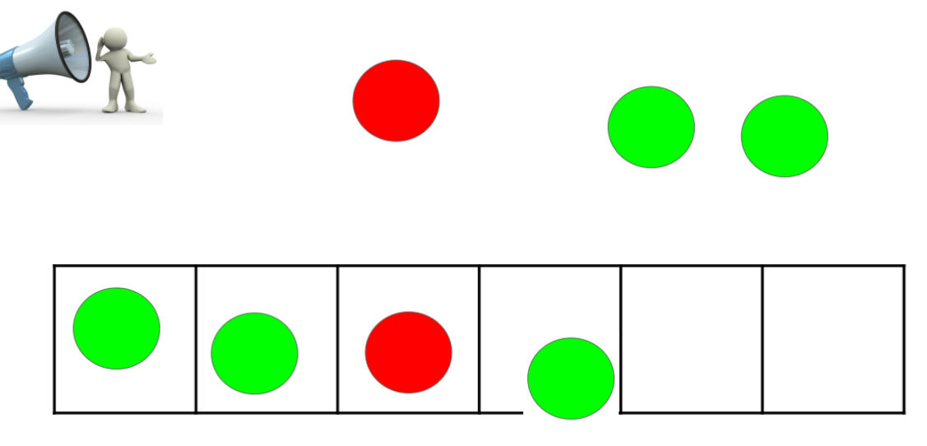
Visual/Kinesthetic
NEW SKILL/CONCEPT
VISUAL DISCOVERY 5-10 Words

(or TCCA)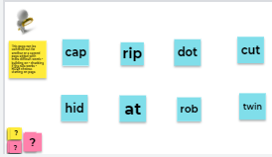
Visual
Reading in context
5-10 Phrases/ Sentences
Auditory-Kinesthetic
Focus on SPELLING
5-10 Sounds
5-10 Words
2-3 Sentences 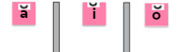

DAY 2 Follow whole class or Small Group
Lesson #2 Date:________________
NEW Lesson Skill or Concept/Objective Con’t
Auditory
Phonemic Awareness
5-10

Visual
Phonograms Cards:
5-10 Sound -Symbol
Auditory/Visual
WORD BUILDING
Chaining 5-10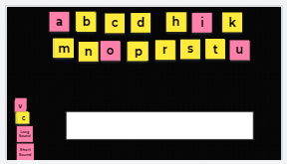
Students use whiteboards or magnetic letters (boards)

Visual
Reading words in isolation
5-10 WORDS
Visual
Reading in context
5-10 Phrases/ Sentences
Auditory-Kinesthetic
Focus on SPELLING
Sounds
Words
Sentences
Visual STORY:

