DAY 1 Lesson # Date:_____________
Concept/Objective  First column some rational on steps | Being word detectives, discover what a silent-e syllable is and identify silent-e patterns in words.
Visual  Phonograms Cards:  Sound -Symbol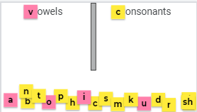 | When I call you, come up, choose a letter, say its sound, and sort it telling us if it is a vowel or consonant. Do an example.
Auditory -Kinesthetic  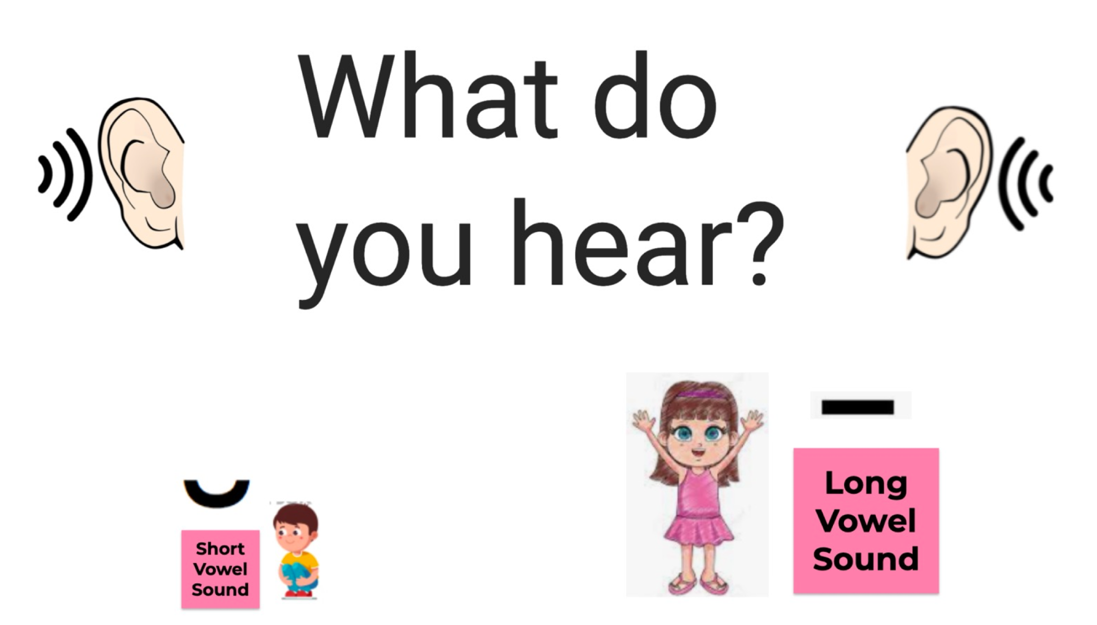 | When I say a word, repeat it, tap it out, and think is it a short or long vowel- make body Short crouching down and if it is a long vowel long stretch up
Auditory  Phonemic Awareness  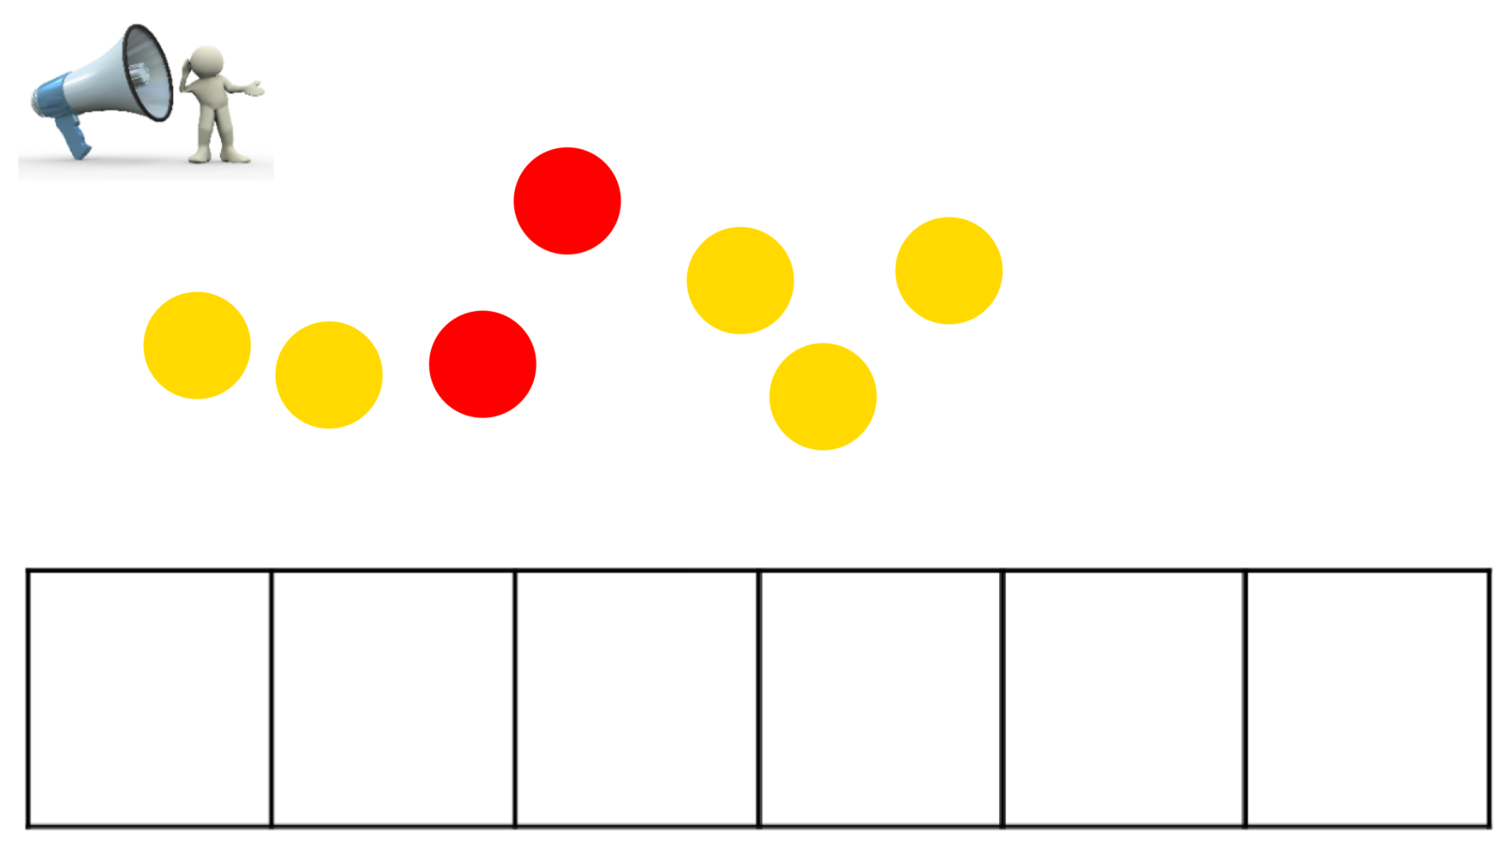 | Listen to the word, say the word, and say each sound as you pull down a chip for each one in the word - the red chip will be for the vowel sound & yellow chips for the consonants.  Here is an example: bike - “bike / b i k/” → pulling-down a chip for each sound→ “bike”  What sound do you hear in that word? “/long i/”  Call students to the board to do a few examples; the rest of the students can say it together - they can tap it out on fingers or tap it out on arms.  ate, cube, theme, bride, scrape  What do you notice about these words and their sounds?  Where do you hear or see the vowel sound? (If needed prompt beginning - middle or end)
Visual/Kinesthetic  NEW SKILL/CONCEPT  DISCOVERY or TCCA  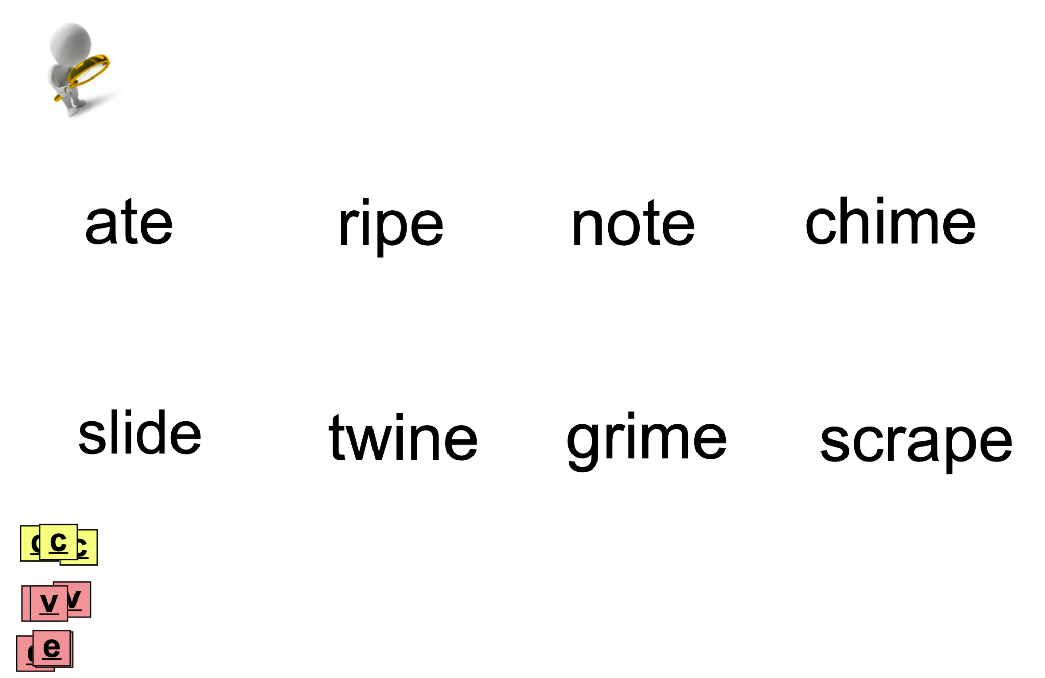  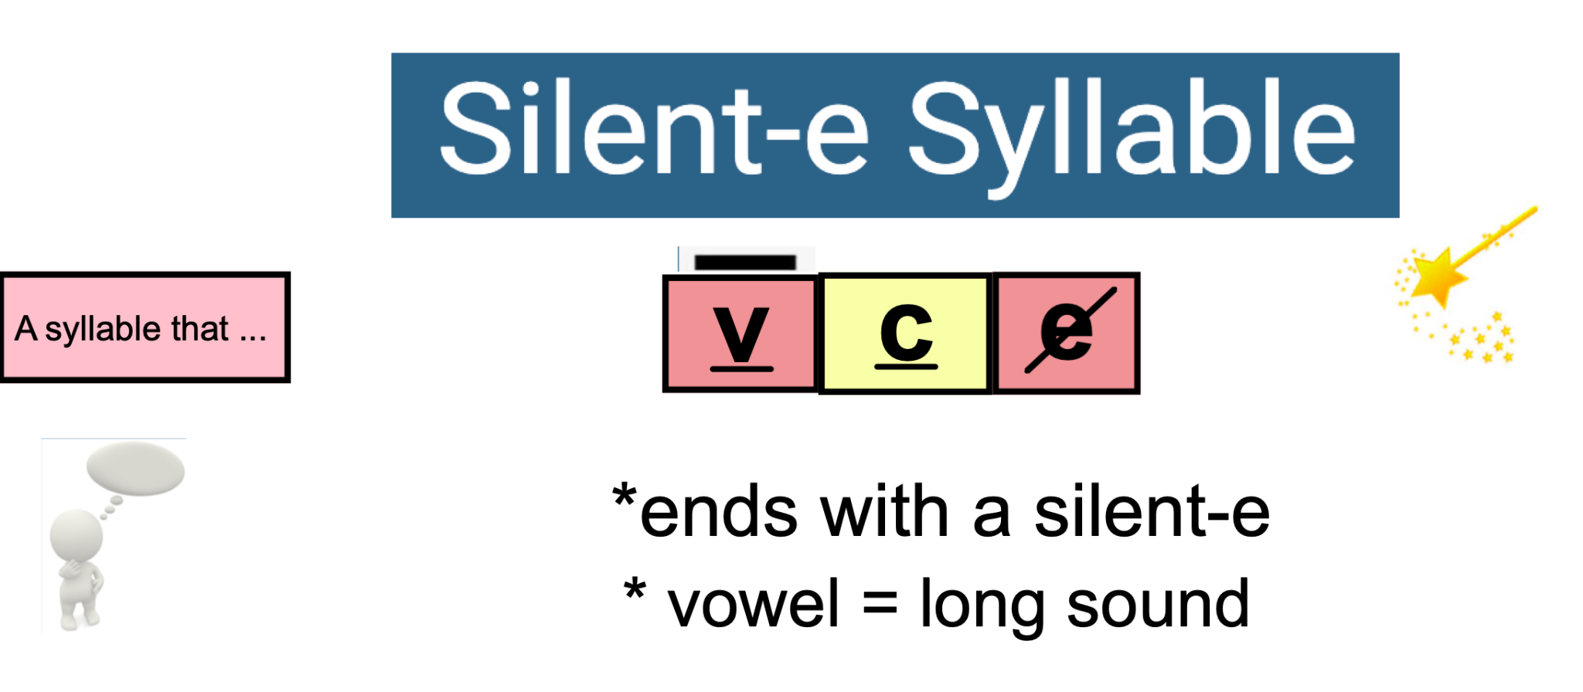 | Let’s read the words aloud (take turns or together)  What do you notice about the words?  Reinforce students feedback and label words with v for vowel and c for consonants and the silent e to see the repeated pattern  Have students label the list of their words on paper with v c e  and then go to  THE NEXT PAGE  Repeat the critical observations when you go to the next page to explicitly state what a closed syllable is  “A silent-e syllable pattern is  vowel -consonant-e and  the vowel is long and  It ends with a silent-e”  REINFORCE and solidify v-e pattern and sounds to end.
ADD-ON → for the future | vce → ace and a-e =“a consonant e says /long a/” etc.

DAY 2 or /& Beyond Lesson #2 Date:________________
 | Review Lesson Skill or Concept/Objective | Being word detectives, discover what a closed syllable is and identify  closed syllables in words.
1. | Visual  Phonograms Cards:  Sound -Symbol  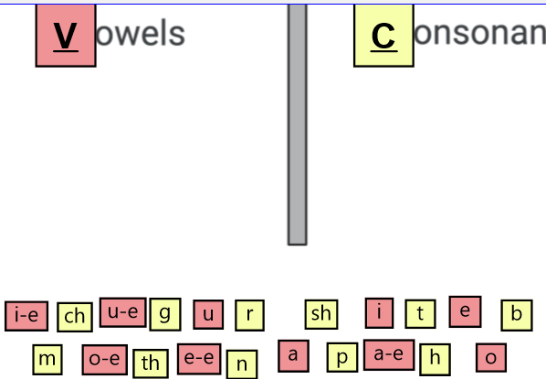 | When I call you come up, choose a letter, say its sound, and sort it telling us if it is a vowel or consonant. USING a-e o-e u-e e-e i-e PHONGRAMS  Do an example.
2. | Visual  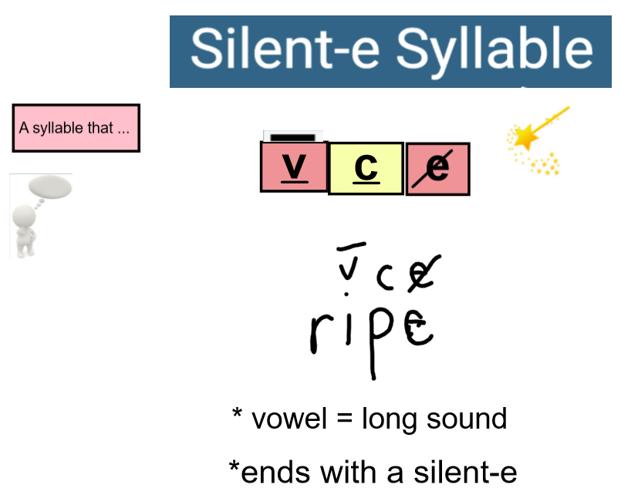 | Review the silent-e syllable type & patterning -- may want to add the long marking over the vowel and give an example of this as well using words from the previous lesson or new words  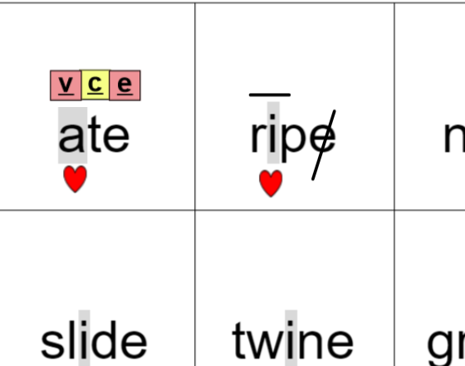
3. | Auditory/Visual  WORD BUILDING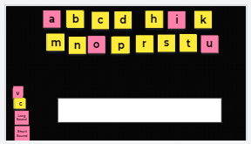  Students use whiteboards or magnetic letters (boards) | 1. Find these sounds to make a word /c/ /long o/ /p/ saying it with time between sounds so that students can blend sounds together. DO WORD BUILDING W/ TILES - STUDENTS CAN USE WHITEBOARDS - CHAINING THE WORDS ONE UNDERNEATH ANOTHER  (Can remind and model the silent e spelling.)  2. Change the /long o / to /long a / - everyone repeat /long o/ to / long a/  Students repeat “/long o/ to /long a/”  3. Choose a student to blend the new sounds & read the new word.  What is the new word ? (cape)  Change /p/ to /k/ (cake) change /k/ to /m/ (make) change /k/ to /m/ (mime)  Change /m/ to /d/ (dime) change /long i / to /long o/ (dome)  What is a dome?
4. | Visual  WORD SORT / READING  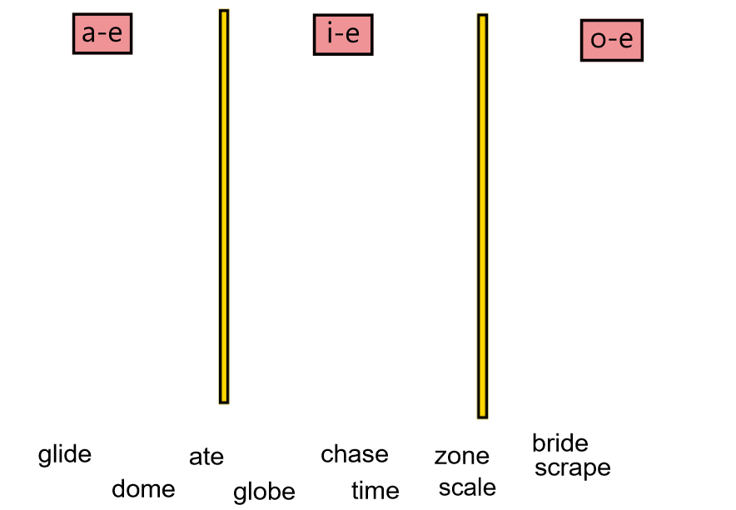 | Review phonograms and explain sorting of a-e i-e and o-e  Have students read & sort words
5. | Visual  Reading in context  Phrases/ Sentences  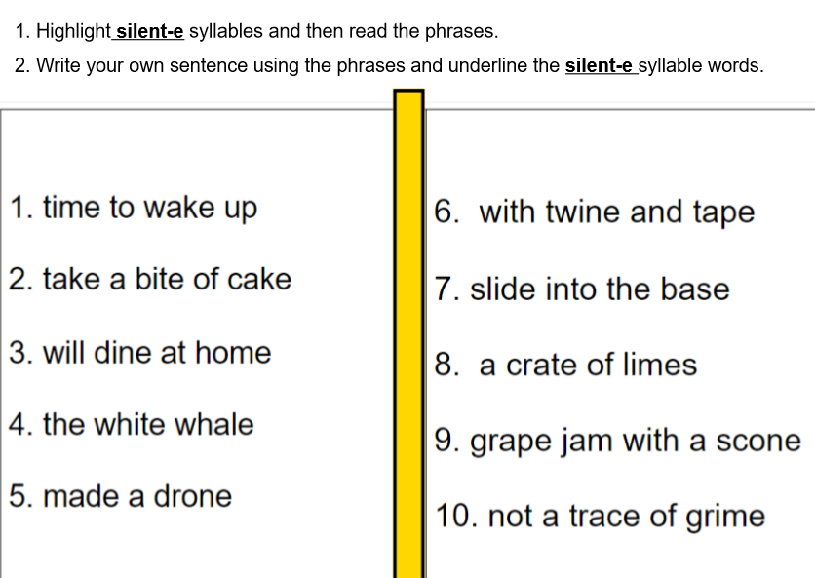 | Have students highlight silent-e syllable words in the phrases  Read the phrases aloud  Have students write two to three sentences using the phrases.
6. | Auditory-Kinesthetic  Focus on SPELLING  Dictation of Sounds &  Words & Sentences  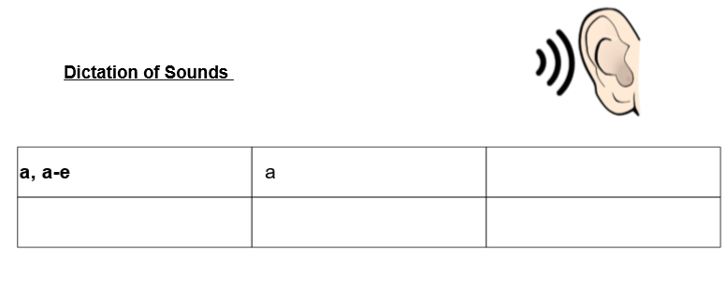  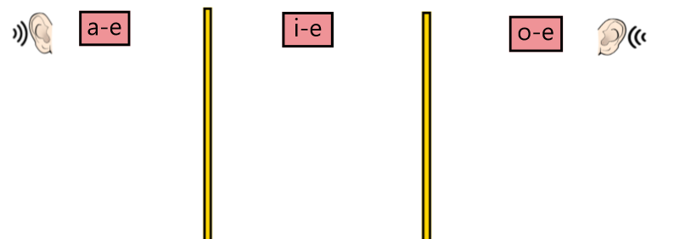 | Model of Dictation of sounds - Say the sound - Student repeats the sounds  Students writes the ways to spell the sound  MODEL 1. /long a/ = a, a-e 2. /short a/ = a  3. /long i/ i, i-e 4. /short o/ o 5. /long o/ o, o-e 6. /sh/ sh  If students add vowel teams after v-e that is fine - check if correct  e.g. a, a-e, ai, ay  Choose words appropriate for your group or class.  Start simple and then build to more complex - can focus on one v-e vowel sound or use a sort similar to the reading of words sort  time, hope, late, chase, shine, globe, slide

ADDITIONAL TEMPLATES / PAGES on SMART NOTEBOOK

- Additional word page for small groups

- Word page with blends / digraphs of words with vc and vce

- Lesson pages for Closed vc vs. Silent-e v-e

- Phoneme - grapheme mapping of silent-e pages and EXAMPLES

