DAY 1 Lesson #1 1st grade Kara Brighindi KHS Date:__12/10/21___________
Concept/Objective  First column some rational on steps |  | Being word detectives, discover what a closed syllable is and identify closed syllables in words.
1.  Starting w/ a familiar task with the students, reinforcing what they know especially vowels vs consonants | Visual  Phonograms Cards:  Sound -Symbol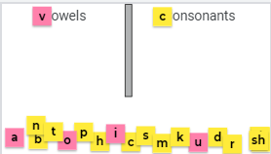 | When I call you come up, choose a letter, say its sound, and sort it telling us if it is a vowel or consonant. Do an example.  You can direct all students to use 2 fingers to write out the chosen letter on the table or carpet while repeating the sound
2.  Again, reinforcing their knowledge & warming up their ears - a new way to do syllable counting. | Auditory  Phonological Awareness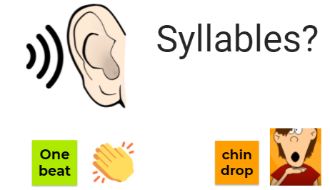 | What is a syllable? (Beat in a word /chin drop/part of a word)  Now you are going to repeat the word & full-body tap - head - hips - knees- toes for the number of syllables in the word - remember first repeat the word “ ???” and tap:  (Do a couple together as needed)  pet, spot, magnet, lunch, fantastic, dentist
3.  Considered listening to words & hearing where the vowel sound is - this type of activity was very possibly too abstract for these students - opted for phoneme mapping & using one color for consonants b/c they were familiar with this already (doing it with irregular SNAP words) | Auditory  Phonemic Awareness  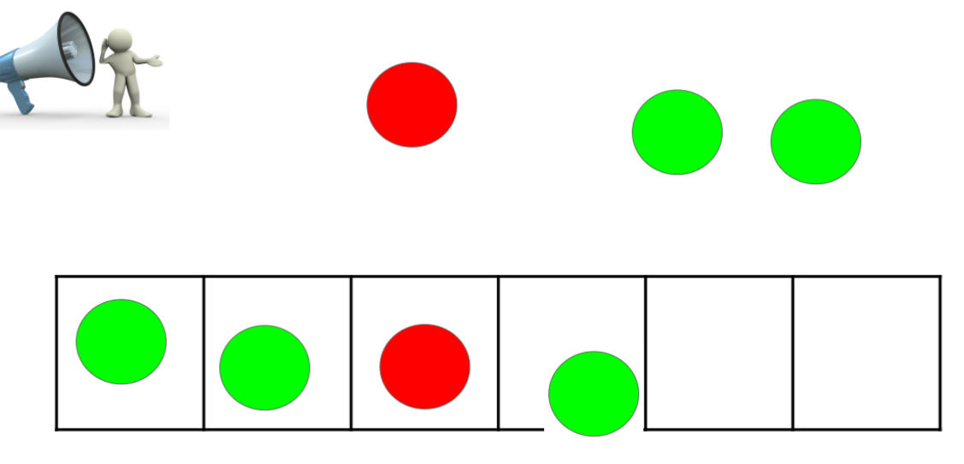 | Listen to the word and pull down a chip for each sound in the word - use a red chip for the vowel sound & green chips for the consonants.  Here is an example: / z i p/ → pulling-down a chip for each sound→ “zip”  Call students to the board to do a few examples; the rest of the students can do it their own PH-GR maps, by tapping fingers or tapping on arms.  tub, sit, spot, last, ship  What do you notice about these words and their sounds?  Where do hear the vowel sound? (If needed prompt beginning - middle or end)
4.  Visual discovery and reinforcing of the patterns - linking it to recent math activities/understanding.  Emphasis on the pattern and the short vowel sounds of the words  **NOTE - a mix of words - some from the Jamboard and some new ones.  Have the students create the Closed Syllable rule on their papers | Visual/Kinesthetic  NEW SKILL/CONCEPT  DISCOVERY or TCCA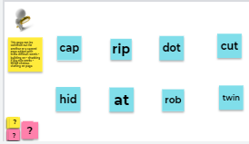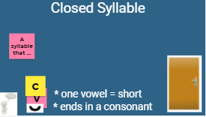 | Let’s read the words aloud (take turns or them together)  What do you notice about the words?  Reinforce students feedback and label words with v for vowel and c for consonants  and the sound the vowel makes  Have students label the list of their words on paper with v c  ON THE NEXT PAGE  Repeat the critical observations when you go to the next page to explicitly state what a closed syllable is  “A closed syllable ends with a consonant and has one vowel that makes the short sound”
5. After checking in w/ students’ work ~ Final activity as a ticket out coming to the closed classroom door | Words on the door -  Open and closed | Demonstrate reading open syllable words - closing the door to make => closed syllables - reinforcing the pattern of the syllable here as a ticket out:)
6.  Another day | Visual  Reading in context  Phrases/ Sentences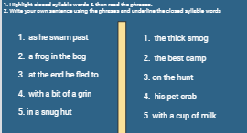 | - Have students highlight closed syllable words in the phrases  - Read the phrases aloud  - Have students write two to three sentences using the phrases.
7.  Another day -  Add in the tapping of words before spelling | Auditory-Kinesthetic  Focus on SPELLING  Words & Sentences | Choose words appropriate for your group or class.  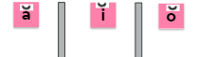

DAY 2 Lesson #2 Date:________________
 | NEW Lesson Skill or Concept/Objective | Being word detectives, discover what a closed syllable is and identify  closed syllables in words.
1. | Auditory  Phonemic Awareness | Listen to the word and pull down a chip for each sound in the word - use a red chip for the vowel sound.  Here is an example: / z i p/ → pulling-down a chip for each sound→ “zip”  Call students to the board to do a few examples; the rest of the students can do it their own PH-GR maps, by tapping fingers or tapping on arms.  tub, sit, spot, last, ship  Where do hear the vowel sound? (If needed prompt beginning - middle or end)
2. | Visual  Phonograms Cards:  Sound -Symbol | When I call you come up, choose a letter, say its sound, and sort it telling us if it is a vowel or consonant. Do an example.  You can direct all students to use 2 fingers to write out the chosen letter on the table or carpet while repeating the sound
3.  Or skip and go to #4  Do another time:) | Auditory/Visual  WORD BUILDING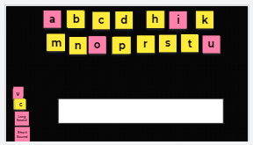  Students use whiteboards or magnetic letters (boards) | 1. Find these sounds to make a word /h/ /i/ /d/ saying it with time between sounds so that students can blend sounds together.  2. Change the /d/ to /t/ - everyone repeat /d/ to /t/  Students repeat “/d/ to /t/”  3. Choose a student to blend the new sounds & read the new word.  What is the new word ??? (hit)  Change /i/ to /o/ (hot) change /h/ to /c/ (cut) change /u/ to /a/ (cat)  Change /c/ to /p/ (pat) change /a/ to /e/ (pet)
3. | VisualReading words in isolation | REVIEW RULE W/ A DIFFERENT SET OF WORDS  Let’s read the words aloud (take turns or them together)  What do you notice about the words?  Reinforce students feedback and label words with v for vowel and c for consonants  and the sound the vowel makes  Have students label the list of their words on paper with v c  ON THE NEXT PAGE  Repeat the critical observations when you go to the next page to explicitly state what a closed syllable is  “A closed syllable ends with a consonant and has one vowel that makes the short sound”
4. | Visual  Reading in context  Phrases/ Sentences | - Have students highlight closed syllable words in the phrases  - Read the phrases aloud  - Have students write two to three sentences using the phrases.
5. | Auditory-Kinesthetic  Focus on SPELLING  Words & Sentences | Choose words appropriate for your group or class.
6. | Visual STORY:

